Game design document

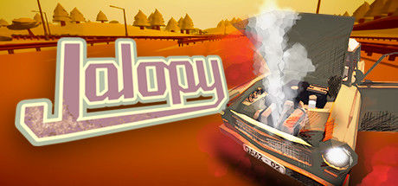

JALOPY
Table of contents

Table of Contents
GAME ANALYSIS 3
MISSION STATEMENT 3
GENRE 3
TARGET AUDIENCE 4
STORYLINE AND CHARACTERS 4
Characters 5
GAMEPLAY 8
MUSIC 9
PLAYER EXPERIENCE 9
GAMEPLAY GUIDELINES 11
GAME OBJECTIVES AND REWARDS 12
GAME MECHANICS 14
Table of components: 14
LEVEL DESIGN 60
CONTROL SCHEME 65
USER INTERFACE 66
SCHEDULE AND TASKS 67

GAME ANALYSIS

“Jalopy” is a automobile simulation game where you can build, repair, refuel and drive a dilapidated old car on a grand journey through the territories of the former Eastern bloc.

MISSION STATEMENT

In “Jalopy” you can experience all the joys and struggles of building and repairing your own car right from the scratch. Learn about cars in a chilling atmosphere in this super realistic car simulation game.

GENRE

- The game is combination of the following genres:
- Automobile simulation
- Driving
- First-Person
- Management
- Survival
- Open World
- Adventure
- Singleplayer
- Indie
- Realistic
- Atmospheric
- Exploration
- Economy
- Sandbox
- Relaxing
- Economy
- Story Rich
- Great Soundtrack

PLATFORMS

- Windows 7/8/10 (64bit) - The game is available for Windows, but support for the Mac OS is planned to release at a later time.

- Xbox One

TARGET AUDIENCE

While there are lots in the space who serve the core audience of serious, rivet-counting simulator enthusiasts, simulators are ultimately sandboxes: you have a set of tools to play with, and everything has been designed to interact with everything else, leaving the door wide up for wanton silliness, if your heart so desires. That paints these games in a different light, showing them as more than the joyless replications of real life they are often perceived to be.

Ten years ago simulation age group was categorically between 45 and 90. Today, there are two distinct groups of players, with a big hole between them. There are kids between eight and fifteen – players who are not yet into FPS or other core genres. Then there is strong 30+ male audience – basically people who have some professional or emotional ties to driving, transportation or repairing industry typically. With all of that on mind, “Jalopy” is also created for and aimed towards two group of player; kids between eight and fifteen and adult males older than thirty.

STORYLINE AND CHARACTERS

In game you navigate through miles and miles of tyre changing, fuel burning, carburettor busting, mud clattering terrain, through night and day, rain and shine. The key is your ability to adapt to whatever the procedurally generated world of Jalopy can throw at you.
Upgrade, maintain and care for your Laika 601 Deluxe motor vehicle. Also, it is crucial you keep close attention to everything from the state of your tyres, the condition of your engine and even the space in your trunk. Repair each aspect of your scrappy little car and install unique upgrades to deal with the changing world. Everything from cargo weight to the condition of your carburettor will determine how your car performs on the open road.
The rise of capitalism brings an economical conundrum. Scavenge for scraps to make a small return of investment, or become a baron of the open road and smuggle contraband under the eyes of border patrols to make a sizable profit.

Characters

Characters | Description | Characteristics
Splat   | The main character. Splat is a male and is currently the only available avatar in Jalopy. He resides in a house / garage with his uncle, known as 'Werner Genosse Lütfi' or 'Sevgili Lütfi'. Splat does not have any dialogue options as of yet and his only known relations thus far are that of his uncle. Splat is tasked with driving his Laika 601 across the region collecting and selling goods along the way in order to turn a profit which is then primarily used to upgrade his Laika along with other miscellaneous things such as hotel fees and various goods. | There is no known description of this character since the game is played from the first person perspective and you never get to see him. It is like you are playing with the first person controller that is included in unity standard assets package.
Uncle Lütfi   | The secondary character. He is Splat's uncle. At the beginning of Jalopy, Uncle will lead you through a brief tutorial and help you build your Laika 601. Splat will have the chance to decide if he wants Uncle to come with him on his journey. Along the way, Uncle would tell various stories that provided comedic relief during long stretches of driving. After staying at the Motel, Uncle will be waiting for you in the car. If you're low on money, the exact amount is unknown, he will give you 60 DM. If you reach Turkey with him, he will leave you, leaving his suitcase with a farewell letter in the Laika. | Uncle is a middle-aged male with short blond hair and blonde face hair. He wears a black vintage “Newsboy" Style Wool Cap, yellow shirt, yellow and black plaid jacket, black pants and brown shoes. He has vast knowledge about cars and is trying to pass that knowledge onto Splat.
The Innkeeper (Liza)  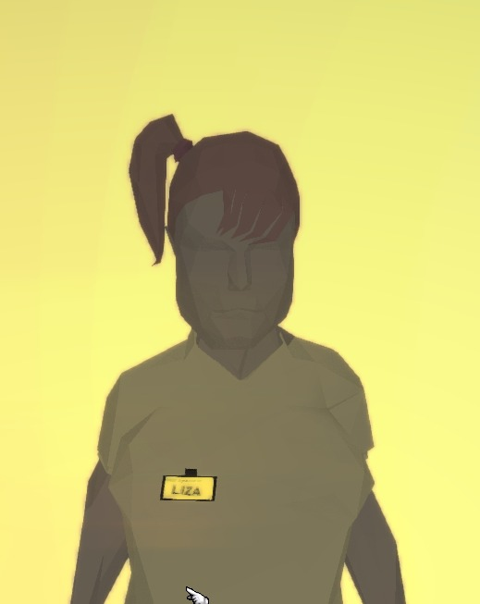 | The innkeeper is a female found inside each town's Motel. She will collect room fees and issue you your room key. She wears a name tag which says: 'Liza' and a 'Mist Öl' shirt in any country. | She has brown hair arranged in ponytail and is wearing yellow T-shirt.
Gas Station clerk   | The clerk is a female found inside each Gas station. She will buy most of your goods and can sell you any item available in her gas station. | She is very helpful and “talkative” young lady always ready to help.
Laika vendor   | The Laika vendor is a male found in each cities Laika Store. He will present you a Laika catalog in which you can order various car parts from. | He has short black hair, is wearing glasses and yellow shirt. He sits behind a desk in his office and will assist you with buying components.
Motel Guest | When you knock on a guest room door in the Motel there's a good chance you'll be greeted with a response. There's a probability the Motel Guest will pay you slightly above the nightly stay for the current Motel. If the guest paid you they will not pay again. Alternatively, they can tell you to leave them alone, knocking multiple times will not result in a different outcome. | There is no known description of this character since you never actually see it. Your only interaction is vocal through the closed motel doors.
Border patrol officer   | As Splat moves from route to route he will pass through many border patrols during which he will interact with the Border Patrol Guards. The Guard in the office decides if you can venture forward and will check your papers and oversee your next route only after you have spent the night at the town Motel. | Border patrol officer can be found only in his office and will participate in routine checks of your car. Classic deck clerk.
Border patrol guard  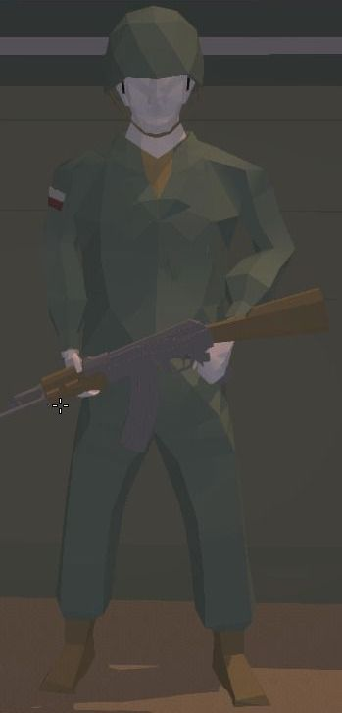 | There are usually three guards at the border and they all look the same. The guard will do a routine check of your vehicle for banned goods. If banned goods are found they will be confiscated, you will be fined, and you will be good to go along your way. | Guards are wearing standard military uniforms and are armed with an AK-74 assault rifle. If they will not check your vehicle for banned goods, they are unmovable and they serve no other purpose.

GAMEPLAY

The game follows the player character known only as Splat and his Uncle Lütfi, two Germans of Turkish descent from Eastern Berlin who have decided to go on a road trip to Istanbul since the Iron Curtain fell. The main task of the game is to get to Istanbul to drop the Uncle off all the while maintaining the Laika (heavily based on the Trabant 601) which is prone to frequent breakdowns signified by smoke coming from the sides of the bonnet. The player passes through East Germany, Czechoslovakia, Hungary, Yugoslavia, Bulgaria and Turkey on his trip with his uncle. The cities he stops in all contain shops important to maintaining his car, and to sell objects found in discarded boxes strewn across the roads on his trip. The player may choose to upgrade the Laika if he has enough money.
When the uncle falls asleep in the hotel, the player can open his briefcase and collect notes that put together a backstory. It turns out the player and the uncle have been separated from the rest of their family residing in West Berlin for almost 30 years because the Uncle was with him as a baby on the East Side the night the Berlin Wall was erected on August 12, 1961.
The uncle has been keeping in contact with the rest of the family, especially his mother, while he kept everything oblivious to him those 30 years. Both of the parents died before the Berlin Wall was torn down, and the mother's last wish was for her husband's ashes to be scattered across the Bosporus when they arrive in Istanbul (which is the reason why Uncle talked his nephew in on going on this seemingly random road trip).
After he drops him off in Istanbul, he is never seen again, with him simply leaving a note telling his nephew that he has to go do something alone and to look after himself and to live his life fully. After that the game never ends. The player can reset from the beginning and do it all over again as many times as he wants. The only difference being Uncle is absent for the entirety of the game.

MUSIC
Music does not play a key part in creating the atmosphere in this game.
You can only listen to the radio music while driving the car, or while the car is turned on. Even tho, the music is really relaxing and it fits in the ambient.
There are some other sounds you can hear while working with car components. It is also worth to mention that characters do not speak any real language but rather imitating it by mumbling at each other.

PLAYER EXPERIENCE

When you first start a new game you will be rudely woken up by an old man in a reality-defying coat. The texture of said coat always looks exactly the same regardless of how you look at it or how the old man is positioned. This old man is known as Uncle Lufti, specifically, he is your uncle.
And the first thing you need to understand is that he is one of the wonkier aspects of the game Weird coat aside, he is extremely forgetful. If you interrupt him, he will forget his place and either repeat what he just said or completely freeze into immobility while trying to find his train of thought. He's also somewhat bad with names too.
Initially, though he'll walk you through building your Laika and explain all the current components you will need to maintain while you play the game. As well as give you advice on how to keep things running relatively smoothly in regards to your car.

At some point you choose to drive all the way to Turkey. To get there, you assemble, drive and desperately maintain your “Laika”–a pixel-perfect Trabant 601, right down to the engine layout–which breaks down constantly for multiple reasons (battery, engine, water, fuel, etc), much like its historical counterpart. Along the way, you stop in motels, refill in gas stations, buy and trade goods across borders, find objects of value along the route, and hope in vain you’ll not have to push your car several miles to the next destination, or run out of money.

But, frankly, one or all these things will happen. That’s the beauty of the game: you simply can’t rely on anything, especially not the game’s mechanics. Drawing virtue from criticism, it feels only right to explain each one of these trappings, just so you know exactly what to expect - and if you’re this game’s target audience.

When you pick your route on the Map, you are also picking the distance you will travel as well as what the weather will be like during your trip. This can add an extra layer of difficulty especially if you haven't properly maintained your Laika.

Like the weather, the conditions of the road also determines how hard it is to drive and how much damage the road might do to your Laika on your journey. Much like with the weather the map warns you if a route has good or bad roads. This also stacks with the effects of weather mentioned in the previous section.

GAMEPLAY GUIDELINES

Weather and Road Condition isn't the only thing you will be informed of when picking a route. Knowing the icons means you will have some idea of the opportunities for salvage and resupply.
Gas Stations
As mentioned before as a place to sell your loot, this is also a place you can get critically needed supplies if you have the money for them. They appear as gas pumps on routes longer than 210 kilometers, which is the max distance you can go to the default Stock Fuel Tank before needing to refuel.
Abandoned Cars
Sometimes you'll stumble across abandoned Laika on cinder blocks, they won't have any doors either. However, they can sometimes have items in the trunk, under the bonnet, or in the seats. It is always a good idea to stop and check them out when you spot them. It's one way of getting free upgrades or items for your car. And like in the above image, they can sometimes spawn with crates nearby.
Junk Yards
If you see a question mark ( ? ) on the route then there is a very good chance that a Junk Yard will spawn. These are locations locked by a puzzle you need to solve in order to get inside, and are usually off on a side road in the manner that Gas Stations can be.
The puzzle is fairly simple, the Yard's gate will be closed with the front end of a Laika acting as a combination lock. The combination being one of the components is either missing, in need of repair, or need of fuel.
You will usually need to use parts from your own car to fit in for any missing components and the Laika Lock needs at least 1 liter of fuel in its tank before pulling the lever replacing the Ignition Coil. If you have everything correct then the engine will start up before opening the gate.
It's smart to immediately yank out any component you inserted immediately as the gate starts to open as the engine will effectively self-destruct in a sense a few seconds after you activate it.
The Junk Yards have a chance at spawning in any engine component on the various shelves littered throughout the yard. These components have a chance of being very good upgrades for your current ones, however, they are usually in extremely bad shape.

GAME OBJECTIVES AND REWARDS

As it was mentioned before, the player’s main objective is reaching a location. Throughout the journey from Berlin to Istanbul, he will encounter challenges and times when things just seem to go wrong. From spinning out during the rain to finding himself in a river due to taking a wrong turn.

Abandoned cars will sometimes have items on the trunk, under the bonnet or in the seats, so they can be a good source of free upgrades for or items for your car. Other great source of free upgrades are junk yards. You can spot them on the side off on a side road. In order to explore them you’ll have to solve a simple puzzle. Once you have done it, you are free to roam through the junk yard and search for any engine components.

Laika Dealership

You can, however, buy upgrades for your Laika at these locations. Such as more storage via the rack, a protective bumper, mud flaps, and replacements for any components with the exception of tires.
If you have the money the replacements you buy can massively increase the performance of your Laika. However, the upgrades found here can be somewhat expensive which means you need to figure out how to make money in order to get these juicy upgrades.
At the Laika Dealership in towns, you are able to buy a storage rack which fits on the roof of your car and allows you to store a bit more, plus an additional two spare tires. Which means you can store a full set of tires. This can prove useful if you need to swap out your tires all at once.

Making a profit

You gain money by selling items or components. Any component that doesn't have zero condition can be sold for the selling price listed when you are holding it. On the road, you will come across boxes, both cardboard and wooden. These boxes contain items that potentially can be worth money or nothing at all. Initially, you can only open cardboard boxes. You do this by carefully clicking on the packing tape holding it closed. Clicking anywhere else on the box will pick it up.
Inside the box, you will find items, some of which are potentially Contraband. When you pick up an item you want to check the selling price, so long as it doesn't say 0.00 then you can sell it at either a Gas Station or Outershop. These items are of various sizes and take up varying amounts of your cargo space. So you have to pick and choose just what items you want. Wooden Boxes work the same way however unlike Cardboard you need a tool to open them. That tool is a crowbar and can sometimes be found at a Gas Station, however your more likely to find one at the Outershop hanging on a cork board display above a car jack.

GAME MECHANICS

As the player will spend most of their time in the game repairing his car, driving it or finding and selling engine various car and engine parts, there is not much significance put on the game graphics. Graphics is rather simple, but it serves its purpose.

In order to maintain your Laika, you need several essential items. These items should always be in either the trunk or on the rack once you get one. So have at least one of the following at the start of your trips:

- Crowbar - Needed to open the wooden boxes.
- Car Jack - Without this, you can't change a blown out tire.
- Jerry Can - Can be used to fill your fuel tank when on the road
- Oil Bottle- Same as the Jerry Can only to help maintain your Fuel Oil Mix
- Spare Tires - Replacement for any blown tires.
- Toolbox - This allows you to make emergency repairs to your engine

Anything else is entirely optional to your tastes and needs. Note on the Jerry and Oil Bottles, they respawn every time you restart in Berlin, however, their contents are persistent. This means if you use them while on the road then those ones will be empty when to restart your run, and will have to be replaced by the newly spawned or bought ones depending on where you are.

Table of components:

Engines:

Component | Description | Price | Stats
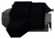  Normal Stock Engine | The normal stock engine is a large and heavy component used to power the vehicle's motion. It's mechanisms are under a black and silver cover, with uncovered bits colored a metallic dark silver. It can be purchased from Laika Dealerships, or found in Abandoned Cars and in the player's Home. The normal stock engine is used as part of the tutorial with Uncle, and will be the first type of engine the player will install in their Laika 601 Deluxe. | 60 DM | Top Speed: 100 km/h  Time: 22.5s for 0-80 km/h  Weight: 54 kg  Durability: 3
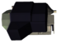  Green Stock Engine | The green stock engine is a large and heavy component used to power the vehicle's motion. It's mechanisms are under a black and green cover, with uncovered bits colored a metallic silver. It can be purchased from Laika Dealerships, or found in Abandoned Cars. | 90 DM | Top Speed: 105 km/h  Time: 22s for 0-80 km/h  Weight: 54 kg  Durability: 3
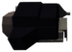  Brown Stock Engine | The brown stock engine is a large and heavy component used to power the vehicle's motion. It's mechanisms are under a black and brown cover, with uncovered bits colored a metallic silver. It can be purchased from Laika Dealerships, or found in Abandoned Cars. | 90 DM | Top Speed: 100 km/h  Time: 22.5s for 0-80 km/h  Weight: 54 kg  Durability: 4
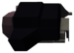  Red Stock Engine | The red stock engine is a large and heavy component used to power the vehicle's motion. It's mechanisms are under a black and red cover, with uncovered bits colored a metallic silver. It can be purchased from Laika Dealerships, or found in Abandoned Cars. | 90 DM | Top Speed: 100 km/h  Time: 22.5s for 0-80 km/h  Weight: 52 kg  Durability: 3
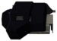  Krone Kong Stock Engine | The krone kong stock engine is a large and heavy component used to power the vehicle's motion. It's mechanisms are under a black and gray cover with the krone kong logo displayed on it, and uncovered bits colored a metallic silver. It can be purchased from Laika Dealerships, or found in Abandoned Cars | 140 DM | Top Speed: 105 km/h  Time: 22s for 0-80 km/h  Weight: 54 kg  Durability: 4
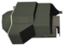  HSK Stock Engine | The HSK stock engine is a large and heavy component used to power the vehicle's motion. It's mechanisms are under a navy green and gray cover with the HSK logo displayed on it, and uncovered bits colored a metallic silver. It can be purchased from Laika Dealerships, or found in Abandoned Cars. | 140 DM | Top Speed: 105 km/h  Time: 22s for 0-80 km/h  Weight: 52 kg  Durability: 3

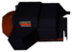  Carbolyte Stock Engine | The carbolyte stock engine is a large and heavy component used to power the vehicle's motion. It's mechanisms are under a black and red cover with the carbolyte logo displayed on it, and uncovered bits colored a metallic black. It can be purchased from Laika Dealerships, or found in Abandoned Cars. | 140 DM | Top Speed: 100 km/h  Time: 22.5s for 0-80 km/h  Weight: 52 kg  Durability: 4

Component | Description | Price | Stats
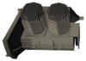  Normal Naked Engine | The normal naked engine is a large and heavy component used to power the vehicle's motion. It's mechanisms are uncovered, showing the combustion chambers of both pistons. Other parts of the engine are colored a metallic gray. It can be purchased from Laika Dealerships, or found in Abandoned Cars. | 160 DM | Top Speed: 110 km/h  Time: 21s for 0-80 km/h  Weight: 50 kg  Durability: 3
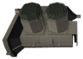  Green Naked Engine | The green naked engine is a large and heavy component used to power the vehicle's motion. It's mechanisms are uncovered, showing the combustion chambers of both pistons. The top portion of the chambers are colored green, with other parts of the engine colored a metallic gray. It can be purchased from Laika Dealerships, or found in Abandoned Cars. | 190 DM | Top Speed: 120 km/h  Time: 20s for 0-80 km/h  Weight: 50 kg  Durability: 3
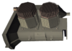  Brown Naked Engine | The brown naked engine is a large and heavy component used to power the vehicle's motion. It's mechanisms are uncovered, showing the combustion chambers of both pistons. The top portion of the chambers are colored brown, with other parts of the engine colored a metallic gray. It can be purchased from Laika Dealerships, or found in Abandoned Cars. | 190 DM | Top Speed: 110 km/h  Time: 21s for 0-80 km/h  Weight: 50 kg  Durability: 4

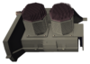  Red Naked Engine | The red naked engine is a large and heavy component used to power the vehicle's motion. It's mechanisms are uncovered, showing the combustion chambers of both pistons. The top portion of the chambers are colored red, with other parts of the engine colored a metallic gray. It can be purchased from Laika Dealerships, or found in Abandoned Cars. | 190 DM | Top Speed: 110 km/h  Time: 21s for 0-80 km/h  Weight: 48 kg  Durability: 3
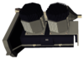  Krone Kong Naked Engine | The krone kong naked engine is a large and heavy component used to power the vehicle's motion. It's mechanisms are uncovered, showing the combustion chambers of both pistons. The top portion of the chambers are colored black, with other parts of the engine colored a metallic black and gray. The krone kong logo is placed on the front of the engine. It can be purchased from Laika Dealerships, or found in Abandoned Cars. | 240 DM | Top Speed: 120 km/h  Time: 20s for 0-80 km/h  Weight: 50 kg  Durability: 4
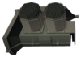  HSK Naked Engine | The HSK naked engine is a large and heavy component used to power the vehicle's motion. It's mechanisms are uncovered, showing the combustion chambers of both pistons. The top portion of the chambers are colored navy green, with other parts of the engine colored a metallic navy green and gray. The HSK logo is placed on the front of the engine. It can be purchased from Laika Dealerships, or found in Abandoned Cars. | 240 DM | Top Speed: 120 km/h  Time: 20s for 0-80 km/h  Weight: 48 kg  Durability: 3
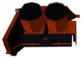  Carbolyte Naked Engine | The carbolyte naked engine is a large and heavy component used to power the vehicle's motion. It's mechanisms are uncovered, showing the combustion chambers of both pistons. The top portion of the chambers are colored black, with other parts of the engine colored a metallic red and black. The carbolyte logo is placed on the front of the engine. It can be purchased from Laika Dealerships, or found in Abandoned Cars. | 240 DM | Top Speed: 110 km/h  Time: 21s for 0-80 km/h  Weight: 48 kg  Durability: 4

Component | Description | Price | Stats
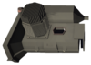  Normal Ramshackle Engine | The normal ramshackle engine is a large and heavy component used to power the vehicle's motion. It's mechanisms are uncovered, showing the combustion chamber of one piston and a hole for where a second piston should be. Other parts of the engine are colored a metallic gray. It can be purchased from Laika Dealerships, or found in Abandoned Cars. | 260 DM | Top Speed: 80 km/h  Time: 20s for 0-80 km/h  Weight: 40 kg  Durability: 3
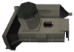  Green Ramshackle Engine | The green ramshackle engine is a large and heavy component used to power the vehicle's motion. It's mechanisms are uncovered, showing the combustion chamber of one piston and a hole for where a second piston should be. The top portion of the chamber is colored green, with other parts of the engine colored a metallic gray. It can be purchased from Laika Dealerships, or found in Abandoned Cars. | 290 DM | Top Speed: 90 km/h  Time: 19s for 0-80 km/h  Weight: 40 kg  Durability: 3
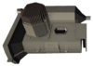  Brown Ramshackle Engine | The brown ramshackle engine is a large and heavy component used to power the vehicle's motion. It's mechanisms are uncovered, showing the combustion chamber of one piston and a hole for where a second piston should be. The top portion of the chamber is colored brown, with other parts of the engine colored a metallic gray. It can be purchased from Laika Dealerships, or found in Abandoned Cars. | 290 DM | Top Speed: 80 km/h  Time: 20s for 0-80 km/h  Weight: 40 kg  Durability: 4
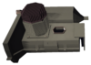  Red Ramshackle Engine | The red ramshackle engine is a large and heavy component used to power the vehicle's motion. It's mechanisms are uncovered, showing the combustion chamber of one piston and a hole for where a second piston should be. The top portion of the chamber is colored red, with other parts of the engine colored a metallic gray. It can be purchased from Laika Dealerships, or found in Abandoned Cars | 290 DM | Top Speed: 80 km/h  Time: 20s for 0-80 km/h  Weight: 38 kg  Durability: 3

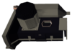  Krone Kong Ramshackle Engine | The krone kong ramshackle engine is a large and heavy component used to power the vehicle's motion. It's mechanisms are uncovered, showing the combustion chamber of one piston and a hole for where a second piston should be. The top portion of the chamber is colored black, with other parts of the engine colored a metallic black and gray. The krone kong logo is placed on the front of the engine. It can be purchased from Laika Dealerships, or found in Abandoned Cars. | 340 DM | Top Speed: 90 km/h  Time: 19s for 0-80 km/h  Weight: 40 kg  Durability: 4
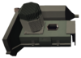  HSK Ramshackle Engine | The HSK ramshackle engine is a large and heavy component used to power the vehicle's motion. It's mechanisms are uncovered, showing the combustion chamber of one piston and a hole for where a second piston should be. The top portion of the chamber is colored navy green, with other parts of the engine colored a metallic navy green and gray. The HSK logo is placed on the front of the engine. It can be purchased from Laika Dealerships, or found in Abandoned Cars. | 340 DM | Top Speed: 90 km/h  Time: 19s for 0-80 km/h  Weight: 38 kg  Durability: 3
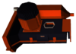  Carbolyte Ramshackle Engine | The carbolyte ramshackle engine is a large and heavy component used to power the vehicle's motion. It's mechanisms are uncovered, showing the combustion chamber of one piston and a hole for where a second piston should be. The top portion of the chamber is colored black, with other parts of the engine colored a metallic red and black. The carbolyte logo is placed on the front of the engine. It can be purchased from Laika Dealerships, or found in Abandoned Cars. | 340 DM | Top Speed: 80 km/h  Time: 20s for 0-80 km/h  Weight: 38 kg  Durability: 4

Component | Description | Price | Stats
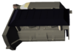  Normal Squash Engine | The normal squash engine is a large and heavy component used to power the vehicle's motion. It's mechanisms are partially uncovered, showing the combustion chambers of both pistons under a lid. The lid is colored black, with other parts of the engine colored a metallic gray. It can be purchased from Laika Dealerships, or found in Abandoned Cars. | 360 DM | Top Speed: 120 km/h  Time: 18s for 0-80 km/h  Weight: 40 kg  Durability: 3
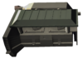  Green Squash Engine | The green squash engine is a large and heavy component used to power the vehicle's motion. It's mechanisms are partially uncovered, showing the combustion chambers of both pistons under a lid. The lid is colored green, with other parts of the engine colored a metallic gray. It can be purchased from Laika Dealerships, or found in Abandoned Cars. | 390 DM | Top Speed: 130 km/h  Time: 17s for 0-80 km/h  Weight: 40 kg  Durability: 3
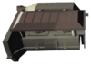  Brown Squash Engine | The brown squash engine is a large and heavy component used to power the vehicle's motion. It's mechanisms are partially uncovered, showing the combustion chambers of both pistons under a lid. The lid is colored brown, with other parts of the engine colored a metallic gray. It can be purchased from Laika Dealerships, or found in Abandoned Cars. | 390 DM | Top Speed: 120 km/h  Time: 18s for 0-80 km/h  Weight: 40 kg  Durability: 4
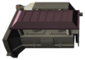  Red Squash Engine | The red squash engine is a large and heavy component used to power the vehicle's motion. It's mechanisms are partially uncovered, showing the combustion chambers of both pistons under a lid. The lid is colored red, with other parts of the engine colored a metallic gray. It can be purchased from Laika Dealerships, or found in Abandoned Cars. | 390 DM | Top Speed: 120 km/h  Time: 18s for 0-80 km/h  Weight: 38 kg  Durability: 3

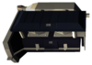  Krone Kong Squash Engine | The Krone Kong Squash Engine is a large and heavy component used to power the vehicle's motion. It's mechanisms are partially uncovered, showing the combustion chambers of both pistons under a lid. The lid is coloured in black, with other parts of the engine coloured in a metallic black and gray. The krone kong logo is displayed on the front of the engine and on top of the lid. It can be purchased from Laika Dealerships, or found in Abandoned Cars. | 440 DM | Top Speed: 160 km/h  Time: 12s for 0-80 km/h  Weight: 40 kg  Durability: 4
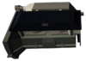  HSK Squash Engine | The HSK squash engine is a large and heavy component used to power the vehicle's motion. It's mechanisms are partially uncovered, showing the combustion chambers of both pistons under a lid. The lid is colored black, with other parts of the engine colored a metallic navy green and gray. The HSK logo is displayed on the front of the engine and on top of the lid. It can be purchased from Laika Dealerships, or found in Abandoned Cars. It can be found in Scrapyards too. | 440 DM | Top Speed: 130 km/h  Time: 17s for 0-80 km/h  Weight: 38 kg  Durability: 3
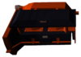  Carbolyte Squash Engine | The carbolyte squash engine is a large and heavy component used to power the vehicle's motion. Its mechanisms are partially uncovered, showing the combustion chambers of both pistons under a lid. The lid is colored black, with other parts of the engine colored a metallic black and red. The carbolyte logo is displayed on the front of the engine and on top of the lid. It can be purchased from Laika Dealerships, or found in Abandoned Cars. | 440 DM | Top Speed: 120 km/h  Time: 18s for 0-80 km/h  Weight: 38 kg  Durability: 4

Fuel tanks:

Component | Description | Price | Stats
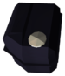  Normal Stock Fuel Tank | The normal stock fuel tank is a large but light component used to store the vehicle's petrol. The container is colored an almost black violet, and the cap is colored a metallic silver. It can be purchased from Laika Dealerships, or found in Abandoned Cars and in the player's Home. The normal stock fuel tank is used as part of the tutorial with Uncle, and will be the first type of fuel tank the player will install in their Laika 601 Deluxe. | 40 DM | Fuel Capacity: 10 liters  Prefilled: 1 liter  Weight: 6 kg  Durability: 3
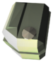  Green Stock Fuel Tank | The green stock fuel tank is a large but light component used to store the vehicle's petrol. The container is colored green, and the cap is colored a metallic silver. It can be purchased from Laika Dealerships, or found in Abandoned Cars. | 60 DM | Fuel Capacity: 11 liters  Prefilled: 5 liters  Weight: 6 kg  Durability: 3
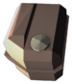  Brown Stock Fuel Tank | The brown stock fuel tank is a large but light component used to store the vehicle's petrol. The container is colored brown, and the cap is colored a metallic silver. Itcan be purchased from Laika Dealerships, or found in Abandoned Cars. | 60 DM | Fuel Capacity: 10 liters  Prefilled: 5 liters  Weight: 6 kg  Durability: 4
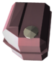  Red Stock Fuel Tank | The red stock fuel tank is a large but light component used to store the vehicle's petrol. The container is colored red, and the cap is colored a metallic silver. It can be purchased from Laika Dealerships, or found in Abandoned Cars. | 60 DM | Fuel Capacity: 10 liters  Prefilled: 5 liters  Weight: 5 kg  Durability: 3
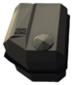  Krone Kong Stock Fuel Tank | The krone kong stock fuel tank is a large but light component used to store the vehicle's petrol. The container is colored gray and black, with the cap colored a metallic silver. The krone kong logo is displayed near the cap. It can be purchased from Laika Dealerships, or found in Abandoned Cars. | 90 DM | Fuel Capacity: 11 liters  Prefilled: 5 liters  Weight: 6 kg  Durability: 4
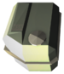  HSK Stock Fuel Tank | The HSK stock fuel tank is a large but light component used to store the vehicle's petrol. The container is colored navy green and gray, with the cap colored a metallic silver. The HSK logo is displayed near the cap. It can be purchased from Laika Dealerships, or found in Abandoned Cars. | 90 DM | Fuel Capacity: 11 liters  Prefilled: 5 liters  Weight: 5 kg  Durability: 3
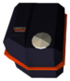  Carbolyte Stock Fuel Tank | The carbolyte stock fuel tank is a large but light component used to store the vehicle's petrol. The container is colored black and red, with the cap colored a metallic silver. The carbolyte logo is displayed near the cap. It can be purchased from Laika Dealerships, or found in Abandoned Cars. | 90 DM | Fuel Capacity: 10 liters  Prefilled: 5 liters  Weight: 5 kg  Durability: 4

Component | Description | Price | Stats
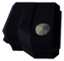  Normal Chubby Fuel Tank | The normal chubby fuel tank is a large but light component used to store the vehicle's petrol. The container is colored an almost black violet, and the cap is colored a metallic silver. It can be purchased from Laika Dealerships, or found in Abandoned Cars. The chubby fuel tanks are slightly longer than their stock counterparts. | 120 DM | Fuel Capacity: 13 liters  Prefilled: 5 liters  Weight: 8 kg  Durability: 3
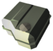  Green Chubby Fuel Tank | The green chubby fuel tank is a large but light component used to store the vehicle's petrol. The container is colored green, and the cap is colored a metallic silver. Itcan be purchased from Laika Dealerships, or found in Abandoned Cars. The chubby fuel tanks are slightly longer than their stock counterparts. | 140 DM | Fuel Capacity: 15 liters  Prefilled: 5 liters  Weight: 8 kg  Durability: 3

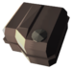  Brown Chubby Fuel Tank | The brown chubby fuel tank is a large but light component used to store the vehicle's petrol. The container is colored brown, and the cap is colored a metallic silver. It can be purchased from Laika Dealerships, or found in Abandoned Cars. The chubby fuel tanks are slightly longer than their stock counterparts. | 140 DM | Fuel Capacity: 13 liters  Prefilled: 5 liters  Weight: 8 kg  Durability: 4
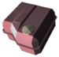  Red Chubby Fuel Tank | The red chubby fuel tank is a large but light component used to store the vehicle's petrol. The container is colored red, and the cap is colored a metallic silver. It can be purchased from Laika Dealerships, or found in Abandoned Cars. The chubby fuel tanks are slightly longer than their stock counterparts. | 140 DM | Fuel Capacity: 13 liters  Prefilled: 5 liters  Weight: 7 kg  Durability: 3
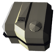  Krone Kong Chubby Fuel Tank | The krone kong chubby fuel tank is a large but light component used to store the vehicle's petrol. The container is colored gray and black, with the cap colored a metallic silver. The krone kong logo is displayed near the cap. It can be purchased from Laika Dealerships, or found in Abandoned Cars. The chubby fuel tanks are slightly longer than their stock counterparts. | 170 DM | Fuel Capacity: 15 liters  Prefilled: 5 liters  Weight: 8 kg  Durability: 4
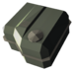  HSK Chubby Fuel Tank | The HSK chubby fuel tank is a large but light component used to store the vehicle's petrol. The container is colored navy green and gray, with the cap colored a metallic silver. The HSK logo is displayed near the cap. It can be purchased from Laika Dealerships, or found in Abandoned Cars. The chubby fuel tanks are slightly longer than their stock counterparts. | 170 DM | Fuel Capacity: 15 liters  Prefilled: 5 liters  Weight: 7 kg  Durability: 3
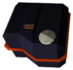  Carbolyte Chubby Fuel Tank | The carbolyte chubby fuel tank is a large but light component used to store the vehicle's petrol. The container is colored black and red, with the cap colored a metallic silver. The carbolyte logo is displayed near the cap. It can be purchased from Laika Dealerships, or found in Abandoned Cars. The chubby fuel tanks are slightly longer than their stock counterparts. | 170 DM | Fuel Capacity: 13 liters  Prefilled: 5 liters  Weight: 7 kg  Durability: 4

Component |  | Price | Stats
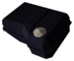  Normal Portly Fuel Tank | The normal portly fuel tank is a large but light component used to store the vehicle's petrol. The container is colored an almost black violet, and the cap is colored a metallic silver. It can be purchased from Laika Dealerships, or found in Abandoned Cars. The portly fuel tanks are much longer than their chubby counterparts. | 200 DM | Fuel Capacity: 22 liters  Prefilled: 5 liters  Weight: 10 kg  Durability: 3
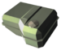  Green Portly Fuel Tank | The green portly fuel tank is a large but light component used to store the vehicle's petrol. The container is colored green, and the cap is colored a metallic silver. It can be purchased from Laika Dealerships, or found in Abandoned Cars. The portly fuel tanks are much longer than their chubby counterparts. | 220 DM | Fuel Capacity: 24 liters  Prefilled: 5 liters  Weight: 10 kg  Durability: 3
  Brown Portly Fuel Tank | The brown portly fuel tank is a large but light component used to store the vehicle's petrol. The container is colored brown, and the cap is colored a metallic silver. It can be purchased from Laika Dealerships, or found in Abandoned Cars. The portly fuel tanks are much longer than their chubby counterparts. | 220 DM | Fuel Capacity: 22 liters  Prefilled: 5 liters  Weight: 10 kg  Durability: 4
  Red Portly Fuel Tank | The Red Portly Fuel Tank is a large but light component used to store the vehicle's petrol. The container is coloured red. It can be purchased from Laika Dealerships or found in Abandoned Cars. The Portly Fuel Tanks are much longer than their Chubby counterparts | 220 DM | Fuel Capacity: 22 liters  Prefilled: 5 liters  Weight: 8 kg  Durability: 3
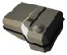  Krone Kong Portly Fuel Tank | The krone kong portly fuel tank is a large but light component used to store the vehicle's petrol. The container is colored gray and black, with the cap colored a metallic silver. The krone kong logo is displayed near the cap. It can be purchased from Laika Dealerships, or found in Abandoned Cars. The portly fuel tanks are much longer than their chubby counterpart | 250 DM | Fuel Capacity: 24 liters  Prefilled: 5 liters  Weight: 10 kg  Durability: 4
  HSK Portly Fuel Tank | The HSK portly fuel tank is a large but light component used to store the vehicle's petrol. The container is colored navy green and gray, with the cap colored a metallic silver. The HSK logo is displayed near the cap. It can be purchased from Laika Dealerships, or found in Abandoned Cars. The portly fuel tanks are much longer than their chubby counterparts. | 250 DM | Fuel Capacity: 24 liters  Prefilled: 5 liters  Weight: 8 kg  Durability: 3

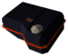  Carbolyte Portly Fuel Tank | The carbolyte portly fuel tank is a large but light component used to store the vehicle's petrol. The container is colored black and red, with the cap colored a metallic silver. The carbolyte logo is displayed near the cap. It can be purchased from Laika Dealerships, or found in Abandoned Cars.  The portly fuel tanks are much longer than their chubby counterparts. | 250 DM | Fuel Capacity: 22 liters  Prefilled: 5 liters  Weight: 8 kg  Durability: 4

Component |  | Price | Stats
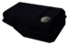  Normal Stout Fuel Tank | The normal stout fuel tank is a large but light component used to store the vehicle's petrol. The container is colored an almost black violet, and the cap is colored a metallic silver. It can be purchased from Laika Dealerships, or found in Abandoned Cars. The stout fuel tanks are even longer than their portly counterparts. | 280 DM | Fuel Capacity: 30 liters  Prefilled: 5 liters  Weight: 12 kg  Durability: 3
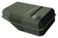  Green Stout Fuel Tank | The green stout fuel tank is a large but light component used to store the vehicle's petrol. The container is colored green, and the cap is colored a metallic silver. It can be purchased from Laika Dealerships, or found in Abandoned Cars. The stout fuel tanks are even longer than their portly counterparts. | 300 DM | Fuel Capacity: 33 liters  Prefilled: 5 liters  Weight: 12 kg  Durability: 3

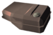  Brown Stout Fuel Tank | The brown stout fuel tank is a large but light component used to store the vehicle's petrol. The container is colored brown, and the cap is colored a metallic silver. It can be purchased from Laika Dealerships, or found in Abandoned Cars. The stout fuel tanks are even longer than their portly counterparts. | 300 DM | Fuel Capacity: 30 liters  Prefilled: 5 liters  Weight: 12 kg  Durability: 4
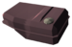  Red Stout Fuel Tank | The red stout fuel tank is a large but light component used to store the vehicle's petrol. The container is colored red, and the cap is colored a metallic silver. It can be purchased from Laika Dealerships, or found in Abandoned Cars. The stout fuel tanks are even longer than their portly counterparts. | 300 DM | Fuel Capacity: 30 liters  Prefilled: 5 liters  Weight: 10 kg  Durability: 3
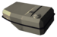  Krone Kong Stout Fuel Tank | The krone kong stout fuel tank is a large but light component used to store the vehicle's petrol. The container is colored gray and black, with the cap colored a metallic silver. The krone kong logo is displayed near the cap. It can be purchased from Laika Dealerships, or found in Abandoned Cars. The stout fuel tanks are even longer than their portly counterparts. | 330 DM | Fuel Capacity: 33 liters  Prefilled: 5 liters  Weight: 12 kg  Durability: 4
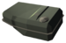  HSK Stout Fuel Tank | The HSK stout fuel tank is a large but light component used to store the vehicle's petrol. The container is colored navy green and gray, with the cap colored a metallic silver. The HSK logo is displayed near the cap. It can be purchased from Laika Dealerships, or found in Abandoned Cars. The stout fuel tanks are even longer than their portly counterparts. | 330 DM | Fuel Capacity: 33 liters  Prefilled: 5 liters  Weight: 10 kg  Durability: 3
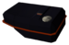  Carbolyte Stout Fuel Tank | The carbolyte stout fuel tank is a large but light component used to store the vehicle's petrol. The container is colored black and red, with the cap colored a metallic silver. The carbolyte logo is displayed near the cap. It can be purchased from Laika Dealerships, or found in Abandoned Cars. The stout fuel tanks are even longer than their portly counterparts. | 330 DM | Fuel Capacity: 30 liters  Prefilled: 5 liters  Weight: 10 kg  Durability: 4

Carburettors:

Component | Descrištion | Price | Stats
  Normal Stock Carburettor | The normal stock carburettor is a small and light component used to blend air and fuel for the engine to use. The part is colored mostly silver and gray, with some parts colored black. It can be purchased from Laika Dealerships, or found in Abandoned Cars and in the player's Home. The normal stock carburettor is used as part of the tutorial with Uncle, and will be the first type of carburettor the player will install in their Laika 601 Deluxe | 30 DM | Km/L: 25  Weight: 5 kg  Durability: 3
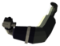  Green Stock Carburettor | The green stock carburettor is a small and light component used to blend air and fuel for the engine to use. The part is colored mostly silver and green, with some parts colored black. It can be purchased from Laika Dealerships, or found in Abandoned Cars. | 45 DM | Km/L: 26  Weight: 5 kg  Durability: 3
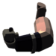  Brown Stock Carburettor | The brown stock carburettor is a small and light component used to blend air and fuel for the engine to use. The part is colored mostly silver and brown, with some parts colored black. It can be purchased from Laika Dealerships, or found in Abandoned Cars. | 45 DM | Km/L: 25  Weight: 5 kg  Durability: 4
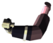  Red Stock Carburettor | The red stock carburettor is a small and light component used to blend air and fuel for the engine to use. The part is colored mostly silver and red, with some parts colored black. It can be purchased from Laika Dealerships, or found in Abandoned Cars. | 45 DM | Km/L: 25  Weight: 4 kg  Durability: 3
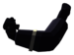  Krone Kong Stock Carburettor | The krone kong stock carburettor is a small and light component used to blend air and fuel for the engine to use. The part is colored mostly silver and an almost black violet, with some parts colored black. The krone kong logo is displayed on the head of the carburettor. It can be purchased from Laika Dealerships, or found in Abandoned Cars. | 60 DM | Km/L: 26  Weight: 5 kg  Durability: 4
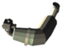  HSK Stock Carburettor | The HSK stock carburettor is a small and light component used to blend air and fuel for the engine to use. The part is colored mostly silver and navy green. The HSK logo is displayed on the head of the carburettor. It can be purchased from Laika Dealerships, or found in Abandoned Cars. | 60 DM | Km/L: 26  Weight: 4 kg  Durability: 3
  Carbolyte Stock Carburettor | The carbolyte stock carburettor is a small and light component used to blend air and fuel for the engine to use. The part is colored mostly silver and red, with some parts colored black. The carbolyte logo is displayed on the head of the carburettor. It can be purchased from Laika Dealerships, or found in Abandoned Cars. | 60 DM | Km/L: 25  Weight: 4 kg  Durability: 4

Component | Description | Price | Stats
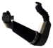  Normal Trough Carburettor | The normal trough carburettor is a small and light component used to blend air and fuel for the engine to use. The part is colored mostly silver and gray, with some parts colored black. It can be purchased from Laika Dealerships, or found in Abandoned Cars. | 80 DM | Km/L: 26  Weight: 7 kg  Durability: 3
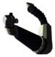  Green Trough Carburettor | The green trough carburettor is a small and light component used to blend air and fuel for the engine to use. The part is colored mostly silver and green, with some parts colored black. It can be purchased from Laika Dealerships, or found in Abandoned Cars. | 95 DM | Km/L: 27  Weight: 7 kg  Durability: 3
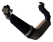  Brown Trough Carburettor | The brown trough carburettor is a small and light component used to blend air and fuel for the engine to use. The part is colored mostly silver and brown, with some parts colored black. It can be purchased from Laika Dealerships, or found in Abandoned Cars. | 95 DM | Km/L: 26  Weight: 7 kg  Durability: 4
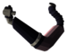  Red Trough Carburettor | The red trough carburettor is a small and light component used to blend air and fuel for the engine to use. The part is colored mostly silver and red, with some parts colored black. It can be purchased from Laika Dealerships, or found in Abandoned Cars. | 95 DM | Km/L: 26  Weight: 6 kg  Durability: 3
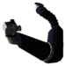  Krone Kong Trough Carburettor | The krone kong trough carburettor is a small and light component used to blend air and fuel for the engine to use. The part is colored mostly silver and an almost black violet, with some parts colored black. The krone kong logo is displayed on the head of the carburettor. It can be purchased from Laika Dealerships, or found in Abandoned Cars. | 110 DM | Km/L: 27  Weight: 7 kg  Durability: 4
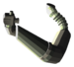  HSK Trough Carburettor | The HSK trough carburettor is a small and light component used to blend air and fuel for the engine to use. The part is colored mostly silver and navy green. The HSK logo is displayed on the head of the carburettor. It can be purchased from Laika Dealerships, or found in Abandoned Cars. | 110 DM | Km/L: 27  Weight: 6 kg  Durability: 3
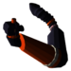  Carbolyte Trough Carburettor | The carbolyte trough carburettor is a small and light component used to blend air and fuel for the engine to use. The part is colored mostly silver and red, with some parts colored black. The carbolyte logo is displayed on the head of the carburettor. It can be purchased from Laika Dealerships, or found in Abandoned Cars. | 110 DM | Km/L: 26  Weight: 6 kg  Durability: 4

Component | Description | Price | Stats
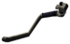  Normal Pipe Carburettor | The normal pipe carburettor is a small and light component used to blend air and fuel for the engine to use. The part is colored mostly silver and gray, with some parts colored black. It can be purchased from Laika Dealerships, or found in Abandoned Cars. | 130 DM | Km/L: 27  Weight: 3 kg  Durability: 3
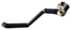  Green Pipe Carburettor | The green pipe carburettor is a small and light component used to blend air and fuel for the engine to use. The part is colored mostly silver and green, with some parts colored black. It can be purchased from Laika Dealerships, or found in Abandoned Cars. | 145 DM | Km/L: 28  Weight: 3 kg  Durability: 3
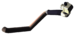  Brown Pipe Carburettor | The brown pipe carburettor is a small and light component used to blend air and fuel for the engine to use. The part is colored mostly silver and brown, with some parts colored black. It can be purchased from Laika Dealerships, or found in Abandoned Cars. | 145 DM | Km/L: 27  Weight: 3 kg  Durability: 4
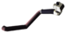  Red Pipe Carburettor | The red pipe carburettor is a small and light component used to blend air and fuel for the engine to use. The part is colored mostly silver and red, with some parts colored black. It can be purchased from Laika Dealerships, or found in Abandoned Cars. | 145 DM | Km/L: 27  Weight: 2 kg  Durability: 3
Krone Kong Pipe Carburettor | The krone kong pipe carburettor is a small and light component used to blend air and fuel for the engine to use. The part is colored mostly silver and an almost black violet, with some parts colored black. The krone kong logo is displayed on the head of the carburettor. It can be purchased from Laika Dealerships, or found in Abandoned Cars. | 160 DM | Km/L: 28  Weight: 3 kg  Durability: 4
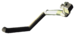  HSK Pipe Carburettor | The HSK pipe carburettor is a small and light component used to blend air and fuel for the engine to use. The part is colored mostly silver and navy green. The HSK logo is displayed on the head of the carburettor. It can be purchased from Laika Dealerships, or found in Abandoned Cars. | 160 DM | Km/L: 28  Weight: 8 kg  Durability: 3
  Carbolyte Pipe Carburettor | The carbolyte pipe carburettor is a small and light component used to blend air and fuel for the engine to use. The part is colored mostly silver and red, with some parts colored black. The carbolyte logo is displayed on the head of the carburettor. It can be purchased from Laika Dealerships, or found in Abandoned Cars. | 160 DM | Km/L: 27  Weight: 2 kg  Durability: 4

Component | Description | Price | Stats
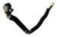  Normal Tube Carburettor | The normal tube carburettor is a small and light component used to blend air and fuel for the engine to use. The part is colored mostly silver and gray, with some parts colored black. It can be purchased from Laika Dealerships, or found in Abandoned Cars. | 180 DM | Km/L: 28  Weight: 2 kg  Durability: 3
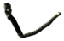  Green Tube Carburettor | The green tube carburettor is a small and light component used to blend air and fuel for the engine to use. The part is colored mostly silver and green, with some parts colored black. It can be purchased from Laika Dealerships, or found in Abandoned Cars. | 195 DM | Km/L: 29  Weight: 2 kg  Durability: 3
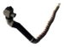  Brown Tube Carburettor | The brown tube carburettor is a small and light component used to blend air and fuel for the engine to use. The part is colored mostly silver and brown, with some parts colored black. It can be purchased from Laika Dealerships, or found in Abandoned Cars. | 195 DM | Km/L: 28  Weight: 2 kg  Durability: 4
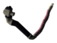  Red Tube Carburettor | The red tube carburettor is a small and light component used to blend air and fuel for the engine to use. The part is colored mostly silver and red, with some parts colored black. It can be purchased from Laika Dealerships, or found in Abandoned Cars. | 195 DM | Km/L: 28  Weight: 1 kg  Durability: 3
  Krone Kong Tube Carburettor | The krone kong tube carburettor is a small and light component used to blend air and fuel for the engine to use. The part is colored mostly silver and an almost black violet. The krone kong logo is displayed on the head of the carburettor. It can be purchased from Laika Dealerships, or found in Abandoned Cars. | 210 DM | Km/L: 29  Weight: 2 kg  Durability: 4
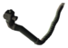  HSK Tube Carburettor | The HSK tube carburettor is a small and light component used to blend air and fuel for the engine to use. The part is colored mostly silver and navy green. The HSK logo is displayed on the head of the carburettor. It can be purchased from Laika Dealerships, or found in Abandoned Cars. | 210 DM | Km/L: 29  Weight: 1 kg  Durability: 3
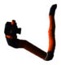  Carbolyte Tube Carburettor | The carbolyte tube carburettor is a small and light component used to blend air and fuel for the engine to use. The part is colored mostly black and red. The carbolyte logo is displayed on the head of the carburettor. It can be purchased from Laika Dealerships, or found in Abandoned Cars. | 210 DM | Km/L: 28  Weight: 1 kg  Durability: 4

Air filters:

Component | Description | Price | Stats
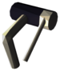  Normal Stock Air Filter | The normal stock air filter is a small and light component used to remove solid particles from the air before it enters the engine, causing additional wear. The tubular-shaped container is colored an almost black violet, with other parts colored a metallic silver. It can be purchased from Laika Dealerships, or found in Abandoned Cars and in the player's Home. The normal stock air filter is used as part of the tutorial with Uncle, and will be the first type of air filter the player will install in their Laika 601 Deluxe. This is a non-essential component, and is not required to start the laika. | 20 DM | Engine Durability Protected: 13.5  Weight: 3 kg  Durability: 3

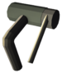  Green Stock Air Filter | The green stock air filter is a small and light component used to remove solid particles from the air before it enters the engine, causing additional wear. The tubular-shaped container is colored green, with other parts colored a metallic silver. It can be purchased from Laika Dealerships, or found in Abandoned Cars. This is a non-essential component, and is not required to start the laika. | 30 DM | Engine Durability Protected: 18.5  Weight: 3 kg  Durability: 3
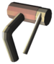  Brown Stock Air Filter | The brown stock air filter is a small and light component used to remove solid particles from the air before it enters the engine, causing additional wear. The tubular-shaped container is colored brown, with other parts colored a metallic silver. It can be purchased from Laika Dealerships, or found in Abandoned Cars. This is a non-essential component, and is not required to start the laika. | 30 DM | Engine Durability Protected: 13.5  Weight: 3 kg  Durability: 4
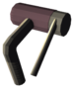  Red Stock Air Filter | The red stock air filter is a small and light component used to remove solid particles from the air before it enters the engine, causing additional wear. The tubular-shaped container is colored red, with other parts colored a metallic silver. It can be purchased from Laika Dealerships, or found in Abandoned Cars. This is a non-essential component, and is not required to start the Laika. | 30 DM | Engine Durability Protected: 13.5  Weight: 2 kg  Durability: 3

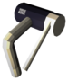  Krone Kong Stock Air Filter | The krone kong stock air filter is a small and light component used to remove solid particles from the air before it enters the engine, causing additional wear. The tubular-shaped container is colored an almost black violet, with other parts colored a metallic silver. The krone kong logo is displayed on the cover. It can be purchased from Laika Dealerships, or found in Abandoned Cars. This is a non-essential component, and is not required to start the la | 40 DM | Engine Durability Protected: 18.5  Weight: 3 kg  Durability: 4
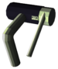  HSK Stock Air Filter | The HSK stock air filter is a small and light component used to remove solid particles from the air before it enters the engine, causing additional wear. The tubular-shaped container is colored an almost black violet, with other parts colored green. The HSK logo is displayed on the cover. It can be purchased from Laika Dealerships, or found in Abandoned Cars. This is a non-essential component, and is not required to start the laika. | 40 DM | Engine Durability Protected: 18.5  Weight: 2 kg  Durability: 3
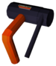  Carbolyte Stock Air Filter | The carbolyte stock air filter is a small and light component used to remove solid particles from the air before it enters the engine, causing additional wear. The tubular-shaped container is colored an almost black violet, with other parts colored red. The carbolyte logo is displayed on the cover. It can be purchased from Laika Dealerships, or found in Abandoned Cars. This is a non-essential component, and is not required to start the laika. | 40 DM | Engine Durability Protected: 13.5  Weight: 2 kg  Durability: 4

Component |  | Price | Stats
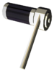  Normal Coverless Air Filter | The normal coverless air filter is a small and light component used to remove solid particles from the air before it enters the engine, causing additional wear. The uncovered filter mesh is colored an almost black violet, with other parts of the component colored a metallic silver. It can be purchased from Laika Dealerships, or found in Abandoned Cars. This is a non-essential component, and is not required to start the laika. | 50 DM | Engine Durability Protected: 18.5  Weight: 3 kg  Durability: 3
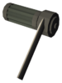  Green Coverless Air Filter | The green coverless air filter is a small and light component used to remove solid particles from the air before it enters the engine, causing additional wear. The uncovered filter mesh is colored green, with other parts of the component colored a metallic silver. It can be purchased from Laika Dealerships, or found in Abandoned Cars. This is a non-essential component, and is not required to start the laika. | 60 DM | Engine Durability Protected: 23.5  Weight: 3 kg  Durability: 3
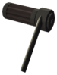  Brown Coverless Air Filter | The brown coverless air filter is a small and light component used to remove solid particles from the air before it enters the engine, causing additional wear. The uncovered filter mesh is colored brown, with other parts of the component colored a metallic silver. It can be purchased from Laika Dealerships, or found in Abandoned Cars. This is a non-essential component, and is not required to start the laika. | 60 DM | Engine Durability Protected: 18.5  Weight: 3 kg  Durability: 4
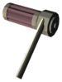  Red Coverless Air Filter | The red coverless air filter is a small and light component used to remove solid particles from the air before it enters the engine, causing additional wear. The uncovered filter mesh is colored red, with other parts of the component colored a metallic silver. It can be purchased from Laika Dealerships, or found in Abandoned Cars. This is a non-essential component, and is not required to start the laika. | 60 DM | Engine Durability Protected: 18.5  Weight: 2 kg  Durability: 3

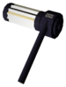  Krone Kong Coverless Air Filter | The krone kong coverless air filter is a small and light component used to remove solid particles from the air before it enters the engine, causing additional wear. The uncovered filter mesh is colored white, with other parts of the component colored an almost black violet. The krone kong logo is displayed near the intake pipe. It can be purchased from Laika Dealerships, or found in Abandoned Cars. This is a non-essential component, and is not required to start the laika. | 70 DM | Engine Durability Protected: 23.5  Weight: 3 kg  Durability: 4
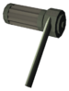  HSK Coverless Air Filter | The HSK coverless air filter is a small and light component used to remove solid particles from the air before it enters the engine, causing additional wear. The uncovered filter mesh is colored grey, with other parts of the component colored navy green. The HSK logo is displayed near the intake pipe. It can be purchased from Laika Dealerships, or found in Abandoned Cars. This is a non-essential component, and is not required to start the laika. | 70 DM | Engine Durability Protected: 23.5  Weight: 2 kg  Durability: 3
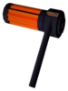  Carbolyte Coverless Air Filter | The carbolyte coverless air filter is a small and light component used to remove solid particles from the air before it enters the engine, causing additional wear. The uncovered filter mesh is colored red, with other parts of the component colored an almost black violet. The carbolyte logo is displayed near the intake pipe. It can be purchased from Laika Dealerships, or found in Abandoned Cars. This is a non-essential component, and is not required to start the lai | 70 DM | Engine Durability Protected: 18.5  Weight: 2 kg  Durability: 4

Component | Description | Price | Stats
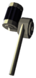  Normal Stubby Air Filter | The normal stubby air filter is a small and light component used to remove solid particles from the air before it enters the engine, causing additional wear. The uncovered filter mesh is colored an almost black violet, with other parts of the component colored a metallic silver. It can be purchased from Laika Dealerships, or found in Abandoned Cars. This is a non-essential component, and is not required to start the laika. | 80 DM | Engine Durability Protected: 23.5  Weight: 3 kg  Durability: 3
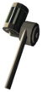  Green Stubby Air Filter | The green stubby air filter is a small and light component used to remove solid particles from the air before it enters the engine, causing additional wear. The uncovered filter mesh is colored green, with other parts of the component colored a metallic silver. It can be purchased from Laika Dealerships, or found in Abandoned Cars. This is a non-essential component, and is not required to start the laika. | 90 DM | Engine Durability Protected: 28.5  Weight: 3 kg  Durability: 3
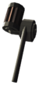  Brown Stubby Air Filter | The brown stubby air filter is a small and light component used to remove solid particles from the air before it enters the engine, causing additional wear. The uncovered filter mesh is colored brown, with other parts of the component colored a metallic silver. It can be purchased from Laika Dealerships, or found in Abandoned Cars. This is a non-essential component, and is not required to start the laika. | 90 DM | Engine Durability Protected: 23.5  Weight: 3 kg  Durability: 4
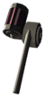  Red Stubby Air Filter | The red stubby air filter is a small and light component used to remove solid particles from the air before it enters the engine, causing additional wear. The uncovered filter mesh is colored red, with other parts of the component colored a metallic silver. It can be purchased from Laika Dealerships, or found in Abandoned Cars. This is a non-essential component, and is not required to start the l | 90 DM | Engine Durability Protected: 23.5  Weight: 2 kg  Durability: 3
  Krone Kong Stubby Air Filter | The krone kong stubby air filter is a small and light component used to remove solid particles from the air before it enters the engine, causing additional wear. The uncovered filter mesh is colored white, with other parts of the component colored an almost black violet. The krone kong logo is displayed below the filter mesh. It can be purchased from Laika Dealerships, or found in Abandoned Cars. This is a non-essential component, and is not required to start the laik | 100 DM | Engine Durability Protected: 28.5  Weight: 3 kg  Durability: 4
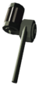  HSK Stubby Air Filter | The HSK stubby air filter is a small and light component used to remove solid particles from the air before it enters the engine, causing additional wear. The uncovered filter mesh is colored gray, with other parts of the component colored navy green. The HSK logo is displayed below the filter mesh. It can be purchased from Laika Dealerships, or found in Abandoned Cars. This is a non-essential component, and is not required to start the laik | 100 DM | Engine Durability Protected: 28.5  Weight: 2 kg  Durability: 3
  Carbolyte Stubby Air Filter | The carbolyte stubby air filter is a small and light component used to remove solid particles from the air before it enters the engine, causing additional wear. The uncovered filter mesh is colored red, with other parts of the component colored an almost black violet. The carbolyte logo is displayed below the filter mesh. It can be purchased from Laika Dealerships, or found in Abandoned Cars. This is a non-essential component, and is not required to start the laika. | 100 DM | Engine Durability Protected: 23.5  Weight: 2 kg  Durability: 4

Component | Description | Price | Stats
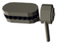  Normal Can Air Filter | The normal can air filter is a small and light component used to remove solid particles from the air before it enters the engine, causing additional wear. The filter mesh is colored an almost black violet, with other parts of the component colored a metallic silver. It can be purchased from Laika Dealerships, or found in Abandoned Cars. This is a non-essential component, and is not required to start the laika. | 110 DM | Engine Durability Protected: 33.5  Weight: 3 kg  Durability: 3
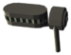  Green Can Air Filter | The green can air filter is a small and light component used to remove solid particles from the air before it enters the engine, causing additional wear. The filter mesh is colored green, with other parts of the component colored a metallic silver. It can be purchased from Laika Dealerships, or found in Abandoned Cars. This is a non-essential component, and is not required to start the laika | 120 DM | Engine Durability Protected: 38.5  Weight: 3 kg  Durability: 3
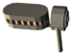  Brown Can Air Filter | The brown can air filter is a small and light component used to remove solid particles from the air before it enters the engine, causing additional wear. The filter mesh is colored brown, with other parts of the component colored a metallic silver. It can be purchased from Laika Dealerships, or found in Abandoned Cars. This is a non-essential component, and is not required to start the laika. | 120 DM | Engine Durability Protected: 33.5  Weight: 3 kg  Durability: 4
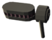  Red Can Air Filter | The red can air filter is a small and light component used to remove solid particles from the air before it enters the engine, causing additional wear. The filter mesh is colored red, with other parts of the component colored a metallic silver. It can be purchased from Laika Dealerships, or found in Abandoned Cars and Junkyards. This is a non-essential component, and is not required to start the laika. | 120 DM | Engine Durability Protected: 33.5  Weight: 2 kg  Durability: 3

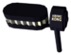  Krone Kong Can Air Filter | The krone kong can air filter is a small and light component used to remove solid particles from the air before it enters the engine, causing additional wear. The filter mesh is colored white, with other parts of the component colored an almost black violet. The krone kong logo is displayed near the intake pipe. It can be purchased from Laika Dealerships, or found in Abandoned Cars. This is a non-essential component, and is not required to start the laika. | 130 DM | Engine Durability Protected: 38.5  Weight: 3 kg  Durability: 4
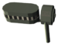  HSK Can Air Filter | The HSK can air filter is a small and light component used to remove solid particles from the air before it enters the engine, causing additional wear. The filter mesh is colored gray, with other parts of the component colored navy green. The HSK logo is displayed near the intake pipe. It can be purchased from Laika Dealerships, or found in Abandoned Cars. This is a non-essential component, and is not required to start the laika. | 130 DM | Engine Durability Protected: 38.5  Weight: 2 kg  Durability: 3
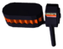  Carbolyte Can Air Filter | The carbolyte can air filter is a small and light component used to remove solid particles from the air before it enters the engine, causing additional wear. The filter mesh is colored red, with other parts of the component colored an almost black violet. The carbolyte logo is displayed near the intake pipe. It can be purchased from Laika Dealerships, or found in Abandoned Cars. This is a non-essential component, and is not required to start the laika | 130 DM | Engine Durability Protected: 33.5  Weight: 2 kg  Durability: 4

Ignition coils:

Component | Desciption | Price | Stats
  Normal Stock Ignition Coil | The normal stock ignition coil is a small and light component. It is used to transform power from the Battery into the required voltage to create a spark in the spark plugs, which will ignite the fuel. The tubular-shaped container is colored a metallic silver and black, with the output terminal wire colored silver. It can be purchased from Laika Dealerships, or found in Abandoned Cars and in the player's Home. The normal stock ignition coil is used as part of the tutorial with Uncle, and will be the first type of ignition coil the player will install in their Laika 601 Deluxe. | 5 DM | Induction Cost: 0.1 liters  Ignition Time: 0.2 seconds  Weight: 1 kg  Durability: 3
  Green Stock Ignition Coil | The green stock ignition coil is a small and light component. It is used to transform power from the Battery into the required voltage to create a spark in the spark plugs, which will ignite the fuel. The tubular-shaped container is colored a metallic green and black, with the output terminal wire colored silver. It can be purchased from Laika Dealerships, or found in Abandoned Cars. | 7.5 DM | Induction Cost: 0.09 liters  Ignition Time: 0.18 seconds  Weight: 1 kg  Durability: 3
  Brown Stock Ignition Coil | The brown stock ignition coil is a small and light component. It is used to transform power from the Battery into the required voltage to create a spark in the spark plugs, which will ignite the fuel. The tubular-shaped container is colored a metallic brown and black, with the output terminal wire colored silver. It can be purchased from Laika Dealerships, or found in Abandoned Cars. | 7.5 DM | Induction Cost: 0.1 liters  Ignition Time: 0.2 seconds  Weight: 1 kg  Durability: 4

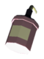  Red Stock Ignition Coil | The red stock ignition coil is a small and light component. It is used to transform power from the Battery into the required voltage to create a spark in the spark plugs, which will ignite the fuel. The tubular-shaped container is colored a metallic red and black, with the output terminal wire colored silver. It can be purchased from Laika Dealerships, or found in Abandoned Cars. | 7.5 DM | Induction Cost: 0.1 liters  Ignition Time: 0.2 seconds  Weight: 0.5 kg  Durability: 3
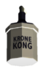  Krone Kong Stock Ignition Coil | The krone kong stock ignition coil is a small and light component. It is used to transform power from the Battery into the required voltage to create a spark in the spark plugs, which will ignite the fuel. The tubular-shaped container is colored a metallic white and black, with the output terminal wire colored silver. The krone kong logo is displayed on the cover. It can be purchased from Laika Dealerships, or found in Abandoned Cars. | 9 DM | Induction Cost: 0.09 liters  Ignition Time: 0.18 seconds  Weight: 1 kg  Durability: 4
  HSK Stock Ignition Coil | The HSK stock ignition coil is a small and light component. It is used to transform power from the Battery into the required voltage to create a spark in the spark plugs, which will ignite the fuel. The tubular-shaped container is colored an almost black violet and black, with the output terminal wire colored white. The HSK logo is displayed on the cover. It can be purchased from Laika Dealerships, or found in Abandoned Cars. | 9 DM | Induction Cost: 0.09 liters  Ignition Time: 0.18 seconds  Weight: 0.5 kg  Durability: 3
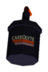  Carbolyte Stock Ignition Coil | The carbolyte stock ignition coil is a small and light component. It is used to transform power from the Battery into the required voltage to create a spark in the spark plugs, which will ignite the fuel. The tubular-shaped container is colored an almost black violet and black, with the output terminal wire colored red. The carbolyte logo is displayed on the cover. It can be purchased from Laika Dealerships, or found in Abandoned Cars. | 9 DM | Induction Cost: 0.1 liters  Ignition Time: 0.2 seconds  Weight: 0.5 kg  Durability: 4

Component | Description | Price | Stats
Normal Barrel Ignition Coil | The normal barrel ignition coil is a small and light component. It is used to transform power from the Battery into the required voltage to create a spark in the spark plugs, which will ignite the fuel. The tubular-shaped container is colored metallic silver and black, with the output terminal wire colored silver. It can be purchased from Laika Dealerships, or found in Abandoned Cars. | 10 DM | Induction Cost: 0.075 liters  Ignition Time: 0.15 seconds  Weight: 2 kg  Durability: 310
Green Barrel Ignition Coil | The green barrel ignition coil is a small and light component. It is used to transform power from the Battery into the required voltage to create a spark in the spark plugs, which will ignite the fuel. The tubular-shaped container is colored metallic green and black, with the output terminal wire colored silver. It can be purchased from Laika Dealerships, or found in Abandoned Cars. | 12.5 DM | Induction Cost: 0.065 liters  Ignition Time: 0.13 seconds  Weight: 2 kg  Durability: 3
  Brown Barrel Ignition Coil | The brown barrel ignition coil is a small and light component. It is used to transform power from the Battery into the required voltage to create a spark in the spark plugs, which will ignite the fuel. The tubular-shaped container is colored metallic brown and black, with the output terminal wire colored silver. It can be purchased from Laika Dealerships, or found in Abandoned Cars. | 12.5 DM | Induction Cost: 0.075 liters  Ignition Time: 0.15 seconds  Weight: 2 kg  Durability: 4
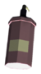  Red Barrel Ignition Coil | The red barrel ignition coil is a small and light component. It is used to transform power from the Battery into the required voltage to create a spark in the spark plugs, which will ignite the fuel. The tubular-shaped container is colored metallic red and black, with the output terminal wire colored silver. It can be purchased from Laika Dealerships, or found in Abandoned Cars. | 12.5 DM | Induction Cost: 0.075 liters  Ignition Time: 0.15 seconds  Weight: 1 kg  Durability: 3

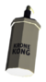  Krone Kong Barrel Ignition Coil | The krone kong barrel ignition coil is a small and light component. It is used to transform power from the Battery into the required voltage to create a spark in the spark plugs, which will ignite the fuel. The tubular-shaped container is colored metallic white and black, with the output terminal wire colored silver. The krone kong logo is displayed on the cover. It can be purchased from Laika Dealerships, or found in Abandoned Cars. | 14 DM | Induction Cost: 0.065 liters  Ignition Time: 0.13 seconds  Weight: 2 kg  Durability: 4
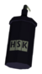  HSK Barrel Ignition Coil | The HSK barrel ignition coil is a small and light component. It is used to transform power from the Battery into the required voltage to create a spark in the spark plugs, which will ignite the fuel. The tubular-shaped container is colored an almost black violet and black, with the output terminal wire colored white. The HSK logo is displayed on the cover. It can be purchased from Laika Dealerships, or found in Abandoned Cars. | 14 DM | Induction Cost: 0.065 liters  Ignition Time: 0.13 seconds  Weight: 1 kg  Durability: 3
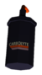  Carbolyte Barrel Ignition Coil | The carbolyte barrel ignition coil is a small and light component. It is used to transform power from the Battery into the required voltage to create a spark in the spark plugs, which will ignite the fuel. The tubular-shaped container is colored an almost black violet and black, with the output terminal wire colored red. The carbolyte logo is displayed on the cover. It can be purchased from Laika Dealerships, or found in Abandoned Cars. | 14 DM | Induction Cost: 0.075 liters  Ignition Time: 0.15 seconds  Weight: 1 kg  Durability: 4

Component | Description | Price | Stats
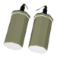  Normal Double Barrel Ignition Coil | The normal double barrel ignition coil is a small and light component. It is used to transform power from the Battery into the required voltage to create a spark in the spark plugs, which will ignite the fuel. The tubular-shaped containers are colored a metallic silver and black, with the output terminal wires colored silver. It can be purchased fromLaika Dealerships, or found in Abandoned Cars. | 15 DM | Induction Cost: 0.05 liters  Ignition Time: 0.1 seconds  Weight: 4 kg  Durability: 3
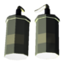  Green Double Barrel Ignition Coil | The green double barrel ignition coil is a small and light component. It is used to transform power from the Battery into the required voltage to create a spark in the spark plugs, which will ignite the fuel. The tubular-shaped containers are colored a metallic green and black, with the output terminal wires colored silver. It can be purchased from Laika Dealerships, or found in Abandoned Cars. | 17.5 DM | Induction Cost: 0.04 liters  Ignition Time: 0.08 seconds  Weight: 4 kg  Durability: 3
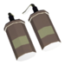  Brown Double Barrel Ignition Coil | The brown double barrel ignition coil is a small and light component. It is used to transform power from the Battery into the required voltage to create a spark in the spark plugs, which will ignite the fuel. The tubular-shaped containers are colored a metallic brown and black, with the output terminal wires colored silver. It can be purchased from Laika Dealerships, or found in Abandoned Cars. | 17.5 DM | Induction Cost: 0.05 liters  Ignition Time: 0.1 seconds  Weight: 4 kg  Durability: 4
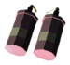  Red Double Barrel Ignition Coil | The red double barrel ignition coil is a small and light component. It is used to transform power from the Battery into the required voltage to create a spark in the spark plugs, which will ignite the fuel. The tubular-shaped containers are colored a metallic red and black, with the output terminal wires colored silver. It can be purchased from Laika Dealerships, or found in Abandoned Cars. | 17.5 DM | Induction Cost: 0.05 liters  Ignition Time: 0.1 seconds  Weight: 2 kg  Durability: 3
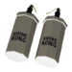  Krone Kong Double Barrel Ignition Coil | The krone kong double barrel ignition coil is a small and light component. It is used to transform power from the Battery into the required voltage to create a spark in the spark plugs, which will ignite the fuel. The tubular-shaped containers are colored a metallic white and black, with the output terminal wires colored silver. The krone kong logo is displayed on both covers. It can be purchased from Laika Dealerships, or found in Abandoned Cars. | 19 DM | Induction Cost: 0.04 liters  Ignition Time: 0.08 seconds  Weight: 4 kg  Durability: 4

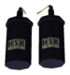  HSK Double Barrel Ignition Coil | The HSK double barrel ignition coil is a small and light component. It is used to transform power from the Battery into the required voltage to create a spark in the spark plugs, which will ignite the fuel. The tubular-shaped containers are colored an almost black violet and black, with the output terminal wires colored silver. The HSK logo is displayed on both covers. It can be purchased from Laika Dealerships, or found in Abandoned Cars. | 19 DM | Induction Cost: 0.04 liters  Ignition Time: 0.08 seconds  Weight: 2 kg  Durability: 3
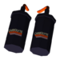  Carbolyte Double Barrel Ignition Coil | The carbolyte double barrel ignition coil is a small and light component. It is used to transform power from the Battery into the required voltage to create a spark in the spark plugs, which will ignite the fuel. The tubular-shaped containers are colored an almost black violet and black, with the output terminal wires colored red. The carbolyte logo is displayed on both covers. It can be purchased from Laika Dealerships, or found in Abandoned Cars. | 19 DM | Induction Cost: 0.05 liters  Ignition Time: 0.1 seconds  Weight: 2 kg  Durability: 4

Component | Description | Price | Stats
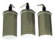  Normal Triple Barrel Ignition Coil | The normal triple barrel ignition coil is a small and light component. It is used to transform power from the Battery into the required voltage to create a spark in the spark plugs, which will ignite the fuel. The tubular-shaped containers are colored a metallic silver and black, with the output terminal wires colored silver. It can be purchased from Laika Dealerships, or found in Abandoned Cars. | 20 DM | Induction Cost: 0.02 liters  Ignition Time: 0.05 seconds  Weight: 5 kg  Durability: 3

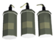  Green Triple Barrel Ignition Coil | The green triple barrel ignition coil is a small and light component. It is used to transform power from the Battery into the required voltage to create a spark in the spark plugs, which will ignite the fuel. The tubular-shaped containers are colored a metallic green and black, with the output terminal wires colored silver. It can be purchased from Laika Dealerships, or found in Abandoned Cars. | 22.5 DM | Induction Cost: 0.01 liters  Ignition Time: 0.025 seconds  Weight: 5 kg  Durability: 3
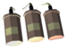  Brown Triple Barrel Ignition Coil | The brown triple barrel ignition coil is a small and light component. It is used to transform power from the Battery into the required voltage to create a spark in the spark plugs, which will ignite the fuel. The tubular-shaped containers are colored a metallic brown and black, with the output terminal wires colored silver. It can be purchased from Laika Dealerships, or found in Abandoned Cars. | 22.5 DM | Induction Cost: 0.02 liters  Ignition Time: 0.05 seconds  Weight: 5 kg  Durability: 4
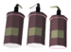  Red Triple Barrel Ignition Coil | The red triple barrel ignition coil is a small and light component. It is used to transform power from the Battery into the required voltage to create a spark in the spark plugs, which will ignite the fuel. The tubular-shaped containers are colored a metallic red and black, with the output terminal wires colored silver. It can be purchased from Laika Dealerships, or found in Abandoned Cars. | 22.5 DM | Induction Cost: 0.02 liters  Ignition Time: 0.05 seconds  Weight: 4 kg  Durability: 3

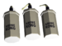  Krone Kong Triple Barrel Ignition Coil | The krone kong triple barrel ignition coil is a small and light component. It is used to transform power from the Battery into the required voltage to create a spark in the spark plugs, which will ignite the fuel. The tubular-shaped containers are colored are colored a metallic white and black, with the output terminal wires colored silver. The krone kong logo is displayed on all three covers. It can be purchased from Laika Dealerships, or found in Abandoned Cars. | 24 DM | Induction Cost: 0.01 liters  Ignition Time: 0.025 seconds  Weight: 5 kg  Durability: 4
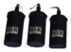  HSK Triple Barrel Ignition Coil | The HSK triple barrel ignition coil is a small and light component. It is used to transform power from the Battery into the required voltage to create a spark in the spark plugs, which will ignite the fuel. The tubular-shaped containers are colored an almost black violet and black, with the output terminal wires colored silver. The HSK logo is displayed on all three covers. It can be purchased from Laika Dealerships, or found in Abandoned Cars. | 24 DM | Induction Cost: 0.01 liters  Ignition Time: 0.025 seconds  Weight: 4 kg  Durability: 3
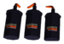  Carbolyte Triple Barrel Ignition Coil | The Carbolyte triple barrel ignition coil is a small and light component. It is used to transform power from the Battery into the required voltage to create a spark in the spark plugs, which will ignite the fuel. The tubular-shaped containers are colored an almost black violet and black, with the output terminal wires colored red. The Carbolyte logo is displayed on all three covers. It can be purchased from Laika Dealerships, or found in Abandoned Cars. | 24 DM | Induction Cost: 0.02 liters  Ignition Time: 0.05 seconds  Weight: 4 kg  Durability: 4

Batteries:

Component | Description | Price | Stats
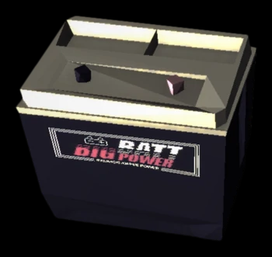  Normal Baterry | The battery is a small and light component that supplies the vehicle with electricity. The electricity is used to power the vehicle's ignition, the headlights, the Radio, the Windshield Wipers and the interior light. It can be purchased from Laika Dealerships, or found in Abandoned Cars and in the player's Home. | 10 DM | Pre-charge: 35%  Durability: 3  Weight:1 kg
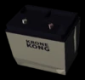  Krone Kong Battery | The battery is used as part of the tutorial with Uncle. | 10 DM | Pre-charge: 35%  Durability: 3  Weight:1 kg

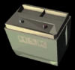  HSK Battery | All of the batteries provided at Laika Dealerships provide the same amount of pre-charge and battery life, and cost the same amount of money. They only serve as re-skins of the normal one. | 10 DM | Pre-charge: 35%  Durability: 3  Weight:1 kg
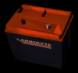  Carbolyte Battery | Batteries lose power when turning on the car (about 1% every start), and when using lights, wipers, or the radio while the engine is not running. Batteries do not recharge while driving, and are the only part of the engine that will need to be replaced eventually. | 10 DM | Pre-charge: 35%  Durability: 3  Weight:1 kg

Water tanks:

Component |  | Price | Stats
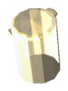  Stock Water Tank | The stock water tank is a small and light component used to store water. The water is utilized by the Windshield Wipers to wet and remove dirt that has accumulated on the windshield. It can be purchased from Laika Dealerships, or found in Abandoned Cars and in the player's Home. The stock water tank is used as part of the tutorial with Uncle, and will be the first type of water tank the player will install in their Laika 601 Deluxe. This is a non-essential component, and is not required to start the laika. | 5 DM | Water Capacity: 0.7 liters  Weight: 1 kg  Durability: 3
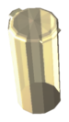  Gazelle Water Tank | The gazelle water tank is a small and light component used to store water. The water is utilized by the Windshield Wipers to wet and remove dirt that has accumulated on the windshield. It can be purchased from Laika Dealerships, or found in Abandoned Cars. This is a non-essential component, and is not required to start the laika. | 10 DM | Water Capacity: 1 liter  Weight: 1 kg  Durability: 3
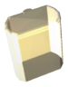  Camel Water Tank | The camel water tank is a small and light component used to store water. The water is utilized by the Windshield Wipers to wet and remove dirt that has accumulated on the windshield. It can be purchased from Laika Dealerships, or found in Abandoned Cars. This is a non-essential component, and is not required to start the laika. | 15 DM | Water Capacity: 2 liters  Weight: 1 kg  Durability: 3

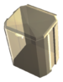  Oasis Water Tank | The oasis water tank is a small and light component used to store water. The water is utilized by the Windshield Wipers to wet and remove dirt that has accumulated on the windshield. It can be purchased from Laika Dealerships, or found in Abandoned Cars. This is a non-essential component, and is not required to start the laika. | 20 DM | Water Capacity: 4 liters  Weight: 1 kg  Durability: 3

Extras:

Component |  | Price | Stats
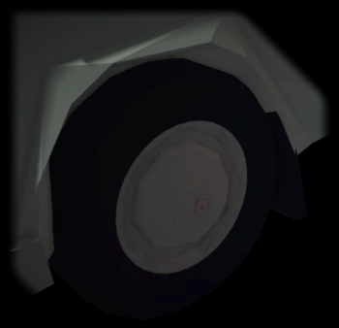  Mud Guards | The mud guards are extra parts that can be added to the player's vehicle. They are installed behind the Tyres and will reduce the rate of speed in which dirt is accumulated on the car during rainy road trips. It can only be purchased from Laika Dealerships. Once purchased, the component will be inside of a cardboard box in front of the laika dealership. The player must use the box behind the tyres, where a glowing silhouette can be found, to install them. Once installed, the player will be unable to remove the component. It will work passively as the player drives the vehicle, and does not require repairs or cleaning. | 25 DM | Water Capacity: 0.7 liters  Weight: 1 kg  Durability: 3

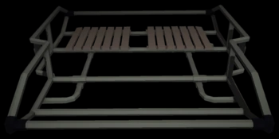  Roof Rack | The roof rack is an extra part that can be added to the player's vehicle. It is installed on the roof of the car, and will expand the storage space available to the player. It can only be purchased from Laika Dealerships. Once purchased, the component will be inside of a cardboard box in front of the laika dealership. The player must use the box on the roof of the vehicle, where a glowing silhouette can be found, to install it.  Once installed, the player will be unable to remove the component. It effectively doubles the storage space of the car, allowing the player to store:  2 extra tyres AND  2 large sized items OR  4 medium sized items OR  18 small sized items  The roof rack does not require repairs or cleaning. | 300 DM | Water Capacity: 1 liter  Weight: 1 kg  Durability: 3
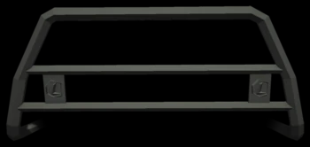  Bull Bar | The bull bar is an extra part that can be added to the player's vehicle. It is installed on the front bumper of the car, and will reduce the amount of damage engine components receive when in collisions. It can only be purchased from Laika Dealerships. Once purchased, the component will be inside of a cardboard box in front of the laika dealership. The player must use the box on the front bumper of the vehicle, where a glowing silhouette can be found, to install it. Once installed, the player will be unable to remove the component, and it does not require repairs or cleaning. | 100 DM | Water Capacity: 2 liters  Weight: 1 kg  Durability: 3
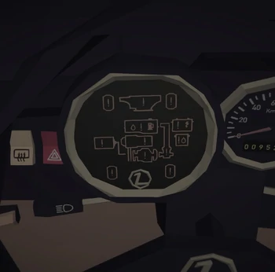  Digital Dash-Display | The Digital Dash-Display component is an extra part that can be added to the player's vehicle. It is installed on the dashboard of the car, and will provide component durability information to the player. It can only be purchased from Laika Dealerships.  Once purchased, the component will be inside of a cardboard box in front of the Laika dealership. The player must use the box on the vehicle, where a glowing silhouette can be found, to install it. As the condition of any part deteriorates, the corresponding icon will illuminate with a yellow color and beep will be sounded by the Digital Dash-Display. When a part reaches 0 durability, or is removed from the car, the display will beep once more and the corresponding icon will illuminate with a red color instead. Some icons will illuminate under more specific conditions, such as the weight icon illuminating as weight increases instead of weight as it decreases. | 400 DM | Water Capacity: 4 liters  Weight: 1 kg  Durability: 3

Tool Rack lvl 1 | The Tool Rack Lvl 1 component is an extra part that can be added to the player's vehicle. It is installed in the trunk of the car, and will provide specialized extra storage to the player. It can only be purchased from Laika Dealerships. Once purchased, the component will be inside of a cardboard box in front of the laika dealership. The player must use the box on the trunk of the vehicle, where a glowing silhouette can be found, to install it. Once installed, the player will be unable to remove the component. It adds tool storage space to the car, allowing the player to store:  1 Car Jack AND  1 Bronze Spanner AND  1 Crowbar  The tool rack does not require repairs or cleaning. The tool rack can be upgraded to a better variant by purchasing the upgrade at a Laika Dealership. It will only appear when the player purchases and installs the Tool Rack Lvl 1 component on their car. | 300 DM | None

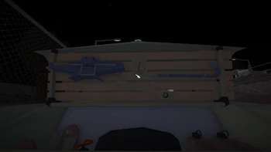  Tool Rack lvl 2 | The tool rack lvl 2 component is an extra part that can be added to the player's vehicle. It is installed in the trunk of the car, and will provide specialized extra storage to the player. It can only be purchased from Laika Dealerships. Once purchased, the component will be inside of a cardboard box in front of the laika dealership. The player must use the box on the trunk of the vehicle, where a glowing silhouette can be found, to install it. Once installed, the player will be unable to remove the component. It adds tool storage space to the car, allowing the player to store:  1 Car Jack AND  1 Silver Spanner AND  1 Crowbar  The tool rack does not require repairs or cleaning. The tool rack can be upgraded to a better variant by purchasing the upgrade at a Laika Dealership. It will only appear when the player purchases and installs the Tool Rack Lvl 2 component on their car. | 400 DM | None
  Tool Rack lvl 3 | The tool rack lvl 3 component is an extra part that can be added to the player's vehicle. It is installed in the trunk of the car, and will provide specialized extra storage to the player. It can only be purchased from Laika Dealerships. Once purchased, the component will be inside of a cardboard box in front of the laika dealership. The player must use the box on the trunk of the vehicle, where a glowing silhouette can be found, to install it. Once installed, the player will be unable to remove the component. It adds tool storage space to the car, allowing the player to store:  1 Car Jack AND  1 Golden Spanner AND  1 Crowbar  The tool rack does not require repairs. | 500 DM | None
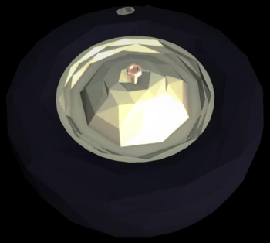  Road Tyre | The tyre is a large component used in conjunction with the engine to move and stop the vehicle. It's colored an almost black violet, with the rim colored a metallic silver. It can be purchased from Petrol Stations or Outershops. It can also be found in Abandoned Cars and in the player's Home.  To replace a tyre, the player must be in possession of a Car Jack. The player must place the jack under the left or right side of the car, and then lift the car up using the crank found on the jack. A lug wrench will then be provided to the player which will allow them to loosen and tighten the singular lug nut found in the center of each tyre. Like any other component, a tyre can be repaired with a Tyre Repair Kit. The car must first be jacked up and the lug nuts loosened. | 50 DM | Max Distance:  450 km - Mileage may vary based on hardness of compound  Traction Limits:  Dry Surfaces  On Roads  Durability: 3  Weight: 10kg When stored in trunk or roof rack
Wet Tyre | A negative correlation exists between tyre traction and tyre compound hardness. As hardness decreases, traction increases and vise versa. With a handful of tyre repair kits, it is possible to prepare for any road condition,and never have to buy tyres again. Using a repair kit and a top rack, it is possible to prepare for any condition with very little handling compromise. Just with the repair kit, keep 2 of each tyre type on your car, for dry conditions offroad tyres at rear and road tyres at front. For wet conditions change out the road tyres for wet tyres. With the roof rack, simply purchase 2 more wet tires. For wet conditions change out all tires for wet, dry conditions have road tyres at front and offroad at rear. When reaching a dirt road swap offroad tyres and road tyres. | 50 DM | Max Distance:  Highly dependent on hardness of compound  Traction Limits  Wet Surfaces  On Roads Only  Durability: 3  Weight: 10kg When stored in trunk or roof rack

Off-Road Tyre | Tyre position matters. At the very least the tyre position impacts the durability of the tyres, with rear showing faster wear.(More deliberate testing needed, or greater verification). Sliding also seems to impact tyre durability, and so should be avoided if one wants to save money.(Verified, but further testing recommended.) The traction of the leading tires on the surface strongly impacts handling, so using the most appropriate tyre type for driving conditions can be beneficial. Furthermore, using softer compound tires at the front may impact handling even more(More testing needed, derived from in-game loading tip.) | 50 DM | Max Distance:  Highly dependent on hardness of compound  Traction Limits  Dry Surfaces  Off Roads  Durability: 3  Weight: 10kg When stored in trunk or roof rack

LEVEL DESIGN
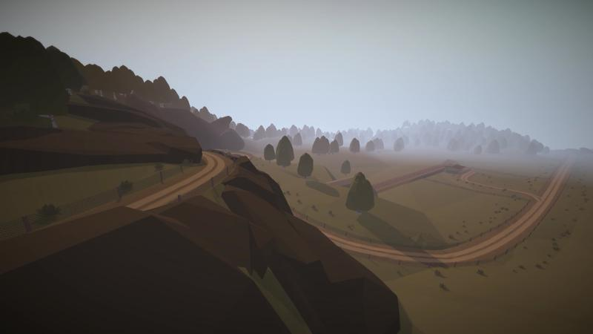

The Map

The map book is a very important item, without it, you are stuck in the starting location. Its primary function is as follows, it gives you three possible routes to choose from. Each route shows the distance in kilometers it will take to get to your next destination. It will also show if there is a gas station on the route, as well as the expected weather and road conditions.
To use it you click on one of the routes, which will eliminate the other two before spawning in the procedurally generated road you just picked. Once the road is complete the gates will open and the weather will change to match what was in the entry.
Once you've driven onto this road the first time, you are no longer at any risk of repeating the tutorial anymore. Also once you have left home you can use the map to Return Home, which after you confirm you wish to do so will fade to back and teleport you back to Berlin. Or use Head back option to drive back to whatever location you were at prior to your last stay in a Motel.

If you change your mind you can use Continue Onward to bring up the next leg of your trip. As long as you haven't selected a route and are not in Berlin switching between the two options can allow you to fine-tune your route until you get the options you want.

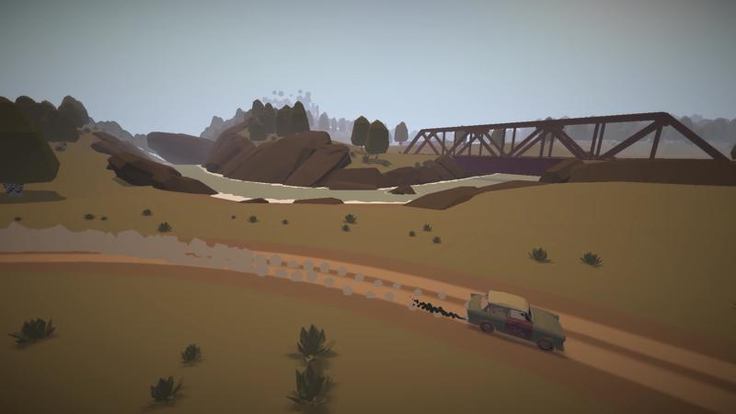
Gas Stations
Gas Stations are indicated on your map by a Gas Pump icon and seem to appear on any route longer than 210 km. With a Stock Fuel Tank, the 210 km distance seems to use up nearly all your fuel.
At Gas Stations you are able to top up your fuel tank and buy any supplies you may need for your journey, so long as said Station has the item in stock. The items in stock are set randomly, so you will not always find what you are looking for.
More importantly, you can sell nearly anything at the Gas Station.

Outershop
The Outershop functions in an identical manner as the Gas Station, it even has a Gas Pump. The main difference is that unlike the Gas Station you can offload any Contraband you have managed to acquire here. The Outershop though only appears in Border Towns, so you can only visit one when you stop in town for the night.

Laika Dealership
Unlike the previous two stores, you can not sell anything at the Dealerships, which like the Outershop only appear in Border Towns. You can, however, buy upgrades for your Laika at these locations. Such as more storage via the rack, a protective bumper, mud flaps, and replacements for any components with the exception of tires.
If you have the money the replacements you buy can massively increase the performance of your Laika. However, the upgrades found here can be somewhat expensive which means you need to figure out how to make money in order to get these juicy upgrades.

Road Conditions

Clear Roads
These are properly maintained and clear of all obstructions and are the easiest to drive down. These are the roads you want to go down if you have a completely stock unmodified Laika. They have no icon to identify them, however, unless you get one of the other road types this is what you will default to. They also seem to have the lowest chance of finding anything other than boxes when it comes to loot and salvage.

Dirty Roads
These roads normally show up in relation to the current weather, they have mud patches sometimes water puddles. Most of the same modifiers as the Clear Roads, however, you are more likely to have a mud-covered Laika by the time you reach the next Border Town.
Rough Roads
Similar to Dirty Roads these are independent of the weather conditions and usually appear with routes having an icon of a car on the edge of the roads. They can have anything that appears on a Dirty Road with the added hazard of potholes. These can send your Laika flipping up into the air and back down again, doing a number on your tires and possibly engine components.
You also have a slightly higher chance of stumbling across an Abandoned Cars which have a chance of goodies you can loot or salvage.
Dirt Roads
After Dresden you have a chance of ending up with these, they seem to pop up randomly and are likely determined by whichever Country you are passing through at the time. They are the second hardest type of road to drive along, especially in bad weather. Offroad Tires, however, are meant for these, and they give an unprepared driver quite a bit of frustration.
Insane Roads
Can be summed up as all of the above, in more quantities as well. They are shown on the map by an icon of a car in a ditch. These are quite literally the hardest roads to drive down period, especially when stacked with weather conditions. Your Laika will, if it manages to survive the trip, be a near total wreck by the time you reach your destination.
This also has a high chance of finding Abandon Cars, so while high risk there is some chance at a reward as well. If your willing to deal with a major repair job once you are done.
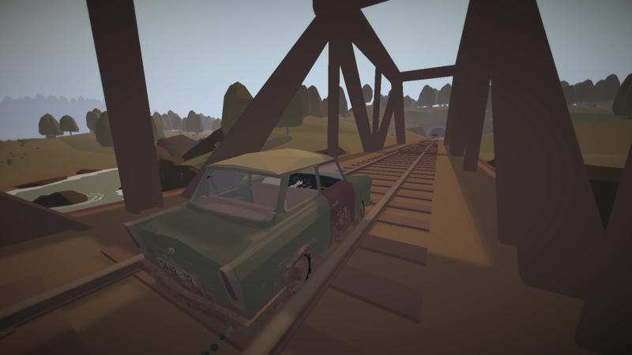


CONTROL SCHEME
Jalopy only allows players to use the keyboard & mouse. Here is a list of all available commands.

Key | Function | Alternate
 | Open Menu, Close Menu, Close books
 | Move your Point-of-View
 | Interact, Pick-up Item
 | Zoom In
  Scroll | Change Item
 | Walk Forward, Accelerate | Up Arrow
 | Walk Backward, Reverse | Down Arrow
 | Move Left, Steer Left | Left Arrow
 | Move Right, Steer Right | Right Arrow
 | Select Item in Position 1
 | Select Item in Position 2
 | Crouch
 | Drop Item | Mouse 3
 | Brake, Jump

USER INTERFACE

In Jalopy, there is no HUD during gameplay. When you first load up the game you will be presented with the main menu similar to this:

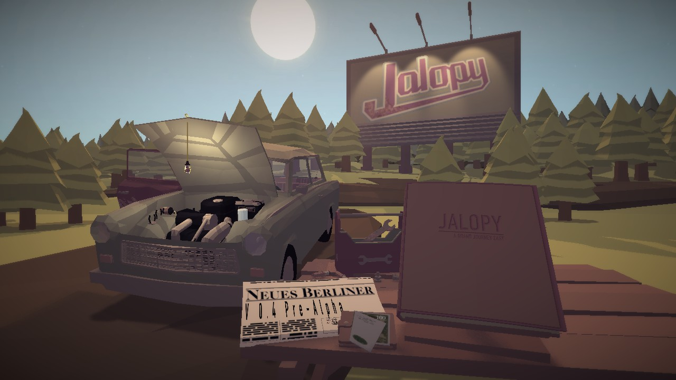
This screen actually changes to show the current state of your save file. The Laika in the scene will actually match the current state of the Laika you drive in the game.

This means any upgrades you install will be visible every time you start up the game. The wallet will actually show your current amount of cash. The toolbox will if clicked open up the options menu. The newspaper will tell you which version of the game you are actually playing.

SCHEDULE AND TASKS
Early Access version of the game (Steam release) was released on Apr 22, 2016. Developers kept on improving the game, refining it, adding more content, improving quality and implementing requests from the community so the game could be finally released on Mar 28, 2018.

Tasks | Task lead | Start | End | % Complete
Created by | Greg Pryjmachuk | 05.01.2015. | Mar 28, 2018 | 100%
Music by | Jeremy Warmsley | 07.08.2015. | Mar 28, 2018 | 100%
Porting and ongoing support by | Arvydas Zemaitis | 04.04.2015. | Mar 28, 2018 | 100%
Assets | Valter - for providing the frame for Yugo 45, James Watson (for providing the frame for the Beatle), Gunstone Art - for providing the loading screen art - gunstone-art.co.uk, Freesound Assets - Sounds | 03.05.2015. | Mar 28, 2018 | 100%
Special Thanks | ''That Guy'', BearInTheAir, Robert, Jane, Bradley, Natasha, Imogen, Spud, Simba, and all of the Pryjmachuk & Brown family, Everyone who purchased during the development period, and all those of you who came later., But most of all, Ezgi | 26.02.2016. | Mar 28, 2018 | 100%
Localisation | Ètienne Leduc-Patenaude(French),Alanwar@Kinukaslove[China],Alejandro Basauri(USA),Alex Croiala(SteGy_k; Canada),Angelo Barato(Wedge; Brazil), Apos [Poland],Bichiş Horia(Romanian),Bogdan Bosiokovic(Serbian),Burak Yolaçan(Turkey), buwad_likon [Chinese],Chloe Seongeun Kim(Korean), Chopei [Korean], DadyGames [Romania], Elit Community [Romania],Dali-Bálint Cscaba(Romania),Danil Gritsenko(Difictly; Estonia),David Koch Gregersen(Denmark),Dávid Virág (Hungarian), Danas Januševičius (Lithuanian), Danil Gritsenko (Russian), Dmitriy Romanov (Dimonasdf), DodgeNish [Bulgarian], Dolphi [French], Dominik Czyszkiewicz (Poland), DStar7 [Brazilian Portuguese], Elsa Platiau (France), Elvis Halupecki (Croatian), Evgeny Makashin (Russia), favorit 'i wanted to do Slovak but Slovak was done' 1 [Czech], Fernando Coun (Argentina), Gábor Cselik (Hungary), Gaston De Keyser, George Gregoriou (Greek), Google61 [Russian], Hakan Karagöz (Turkey), Heitor R. Bernardes (Portuguese), Henry Kaiser (Germany), Hidde Klein Nagelvoort (The Netherlands), Homok Olivér (Xenox; Hungarian), Igor Giorcelli (Italy), Igor Zbiciak (Polish), Ihavepinkwhale [Romanian], Ivan Budé (Netherlands), Jacob Rådström (Sweden), Jakub Topoliński (kubikill; Poland), Javierseja [Spanish], Ketrab [Poland], KSP Jebediah [Latvia], Leonardo Herrmann (Czech), LeYao Li (P.R. China), Luca Gubellini (Italy), Lucas Toftås (Swedish), Lukas M. Pirstnig (German), M. Lemasov (Russian), Madpavsam; fan of Jalopy from the beginning [Russia], Marcus Rattman, Mateian Tudor (Romanian), Matheus Daveli Sampaio (Brazil), Matheus Smith Tavares de Souza (Brazil), Michał Kamiński (Bryl; Poland), MissMuntze [Argentina], NeXoN [Ukranian], Nico Stenfors (Swedish), NikTM [Danish], Oğuzhan Gözdoğan (Turkey), Oscar Holmes (Hungary), OuDacai [China], Pat&Pol [Poland], Pavel Kryuchkov Allpline (Ukraine), Pedroo45 [Brazil], PlayPrey [Norwegian], Poker134 [Canada], popoles [Czech Republic], Porti [Turkey], Ricard Corcuera (Spain), Riki [Italian], Robin Lind (TheFatalLime; Sweden), Romchig - Rushplay [Russia], Romashka Rushplay [Russian], Rufus Briem (Sweden), Sergio Z. Paschoal (Brazil), Shannon Klimek (USA), Sirpotet [Norwegian], Sony [Poland], Sraaronrock [Spain], SrDant3 [Portuguese], Takotubo [Japan], Tamás Herceg (Hungary), TAWASHI [Japan], Teodor Tosevski (Macedonian), Thebab [Turkey], TheHyller [Czech], Tomáš Loun (Czech), Torktumlaren [Sweden], Tóth Gergely (Gerzsony; Hungary), Truebamateo, UnitedMel [Russia], Uvvi [Ukrainian], vb[Chinese spelling] [China], VictorGamer072YT [Brazilian Portuguese], Vilmer Melke (Swedish), Vitya [Hungarian], yaroslavthesmith [Russia], Yasha Malamyzhev (the wrench guy; Russia), Yordan Hristov (Dantcho; Bulgarian), Yozh [Ukrainian], Yunus-Emre Akyildiz (Germany), Zalinka Jrr (Romania), [Russian spelling] [Russia], [Chinese spelling] [Australia], [Chinese spelling] [Chinese] | 15.10.2015. | Mar 28, 2018 | 100%

